## Install NodeJs

Download pkg file from nodeJS site

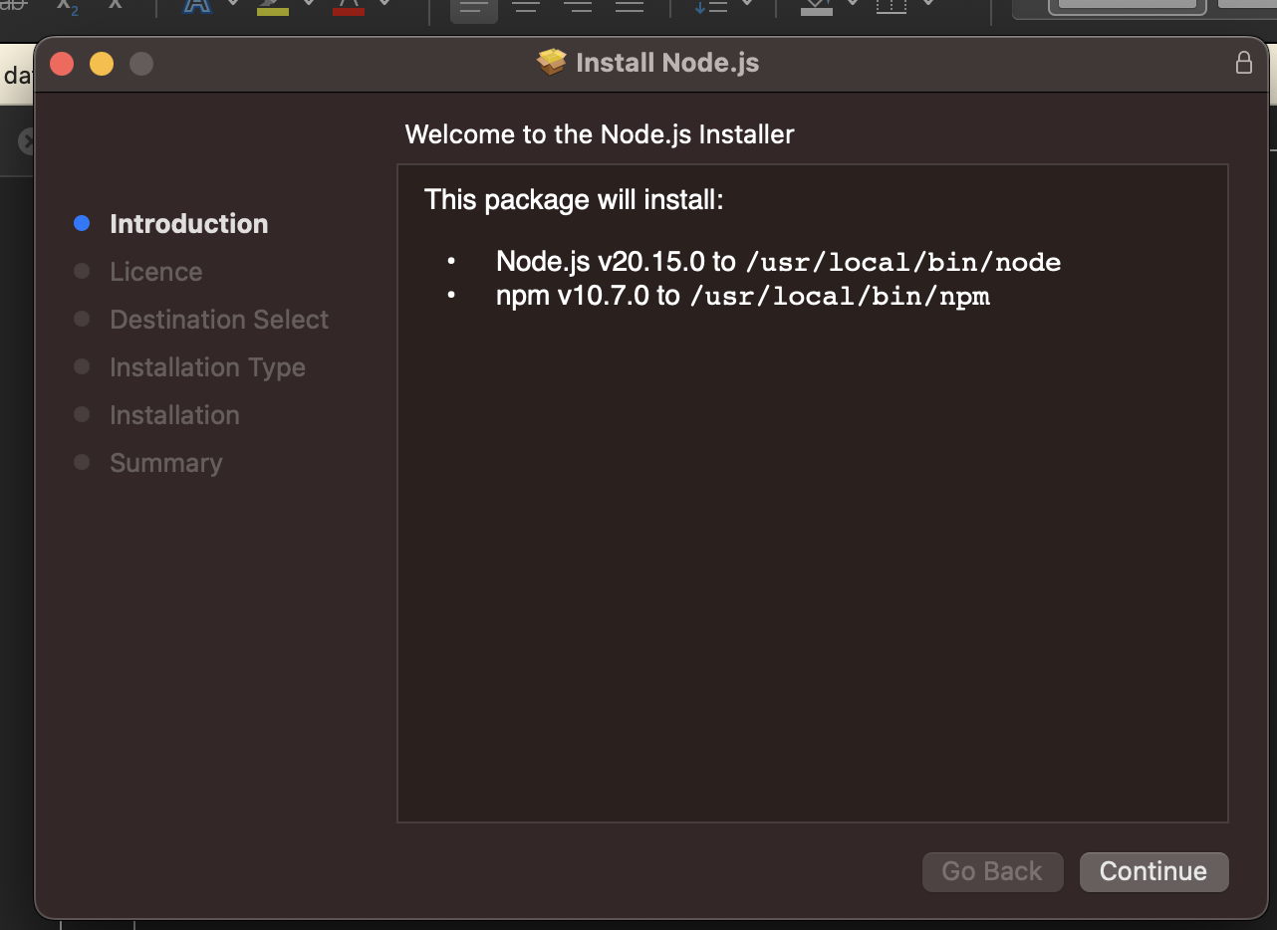

Now it shows the path where nodeJS is installed, we have to have /usr/local in the PATH variable , else edit the PATH variable and add it

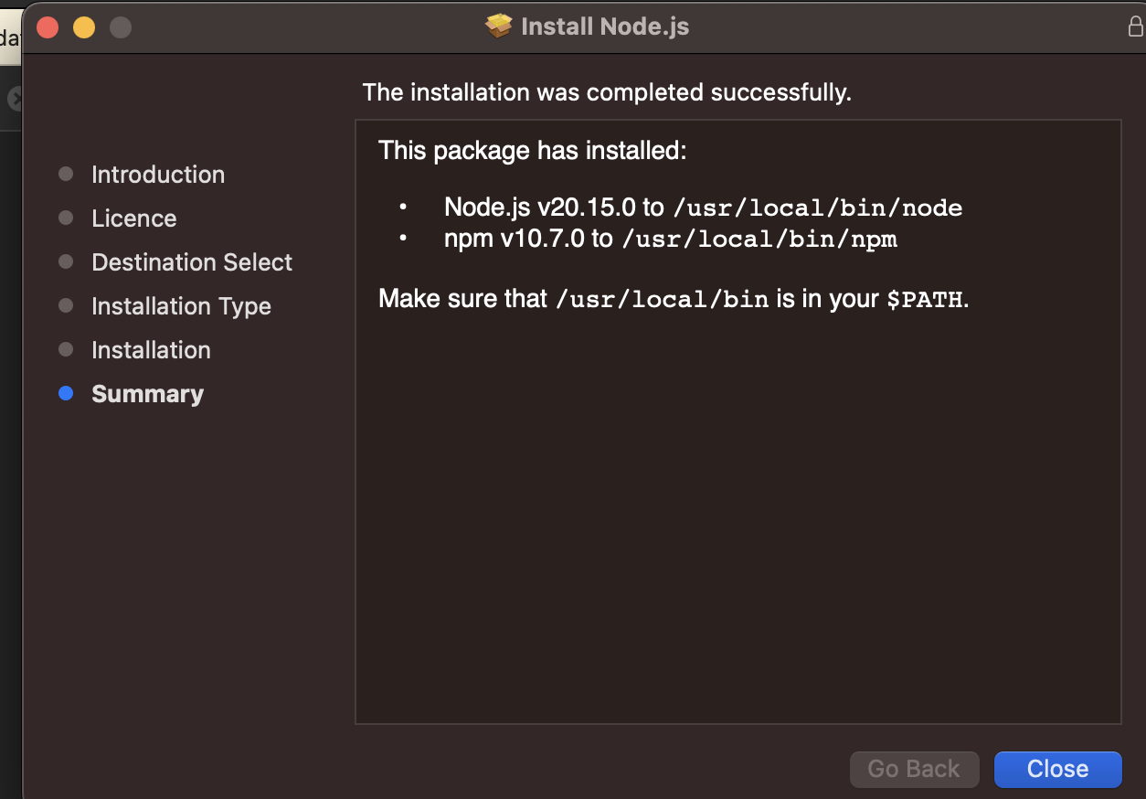

Check in the terminal

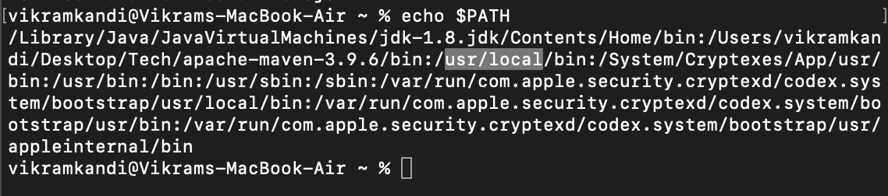

## Install VScode

Download and install vscode which is used as editor

## Install npm project

Open vscode editor

Open folder – create a folder

Go to vscode terminal and give the command %npm init playwright

Provide yes for all the questions – choose javascript

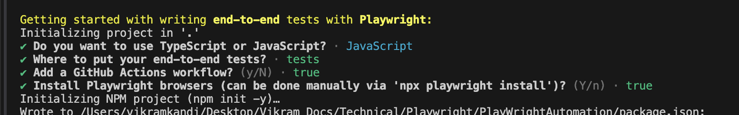

All the associated files and softwares are downloaded and a structure is created as below

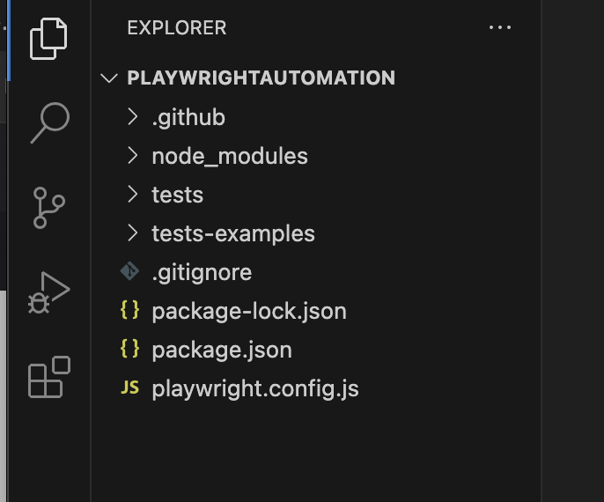

## Execution Commands:

npx playwright test

Runs the end-to-end tests.

npx playwright test --ui

Starts the interactive UI mode.

npx playwright test --project=chromium

Runs the tests only on Desktop Chrome.

npx playwright test example

Runs the tests in a specific file.

npx playwright test --debug

Runs the tests in debug mode.

npx playwright codegen

Auto generate tests with Codegen.

We suggest that you begin by typing:

npx playwright test

### Run only one test

Give test.only then that test only runs

### Run only one file where tests are present

npx playwright test tests/filename

### Run by opening UI runner

npx playwright test --ui

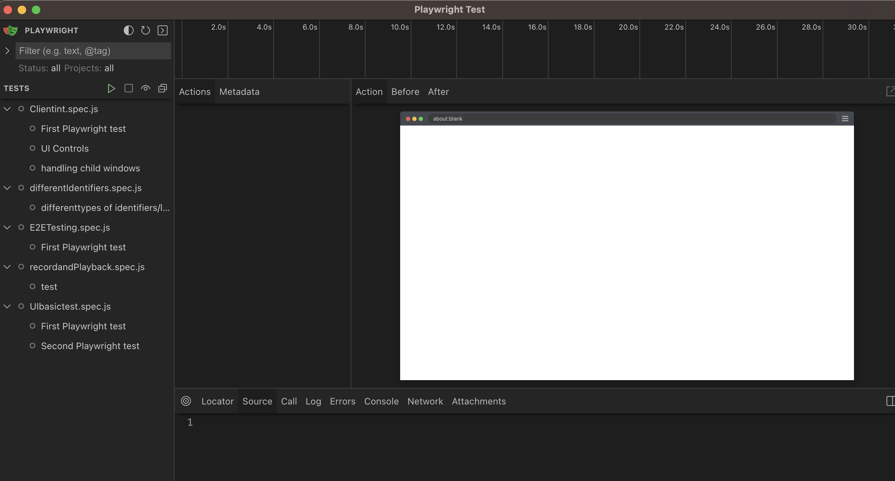

After running you can see all the steps

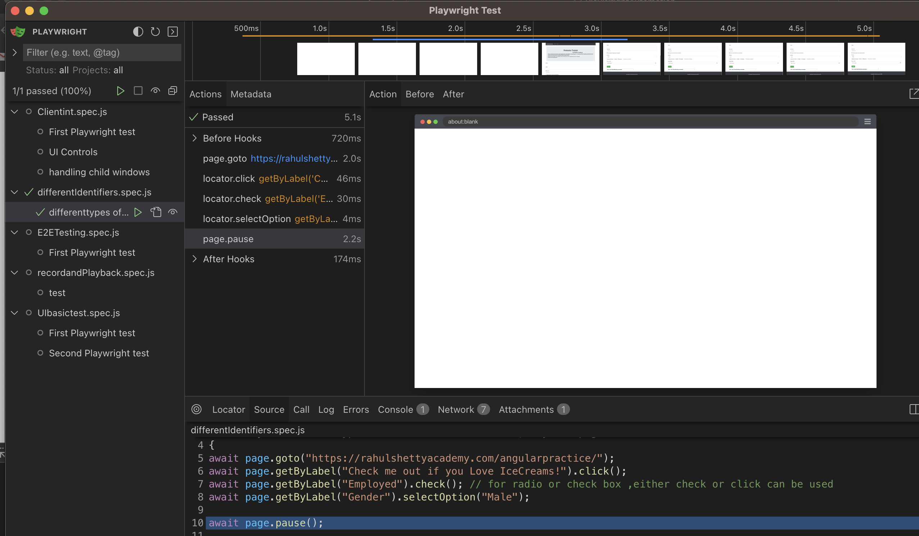

### Identifying CSS/Xpath

Download selectorshub or cropath

Go to the page where you need to identify the objects, F12, select the object then go to selectorshub

give

#### ID

#id or tagname#id for id

#### classname

.classname or tagname.classnam for classname

If there is a space between classname like below, then you can use the name before or after the space

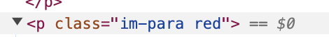

Here class name can be im-para or red

#### Any Attribute

[attribute =’value’]

#### Parent to child

Traversing from parent to child

Css 🡪 parenttagname space childtagname

For text

Text =’ ‘

### Debug

To debug give –debug at the end of the run command like below

npx playwright test --debug

#### To debug api

then

Provide the below in package.json

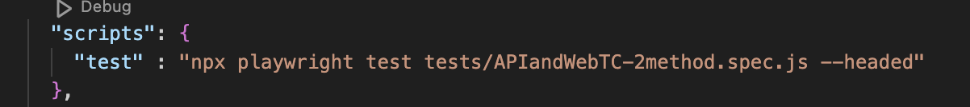

"scripts": {

"test" : "npx playwright test tests/APIandWebTC-2method.spec.js --headed"

},

Then put a break point

And type Debug: Debug npm Script( shift + command + p)

### Record and Playback

npx playwright codegen <https://google.com>

### Logging all the info

Go to playwright.config.js

use: {

browserName : 'chromium',

headless : false,

screenshot : 'on',

trace: ‘on’, // trace : 'on' - this will give trace for all the test cases, 'off' will off all the traces, 'retain-on-failure' will give only failed traces

},

Make trace as on and you can see the details after the execution happened from test-results folder

### Reports

Once you run the test with screenshot and trace options enabled in playwright.config.js, under test-results, you can see the report for the testcase run

Also report can be found under playwright-report folder

#### Traces

Once the run is completed

Navigate to playwright-report 🡪 indext.html (copy path)

Paste this path in browser

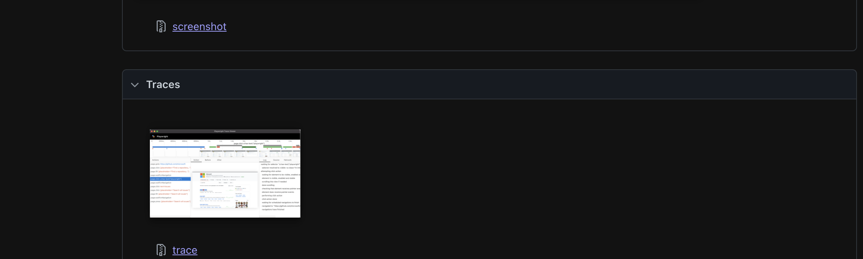

Download the trace, it will be a zip file

Goto trace.playwright.dev

Select the downloaded zip file

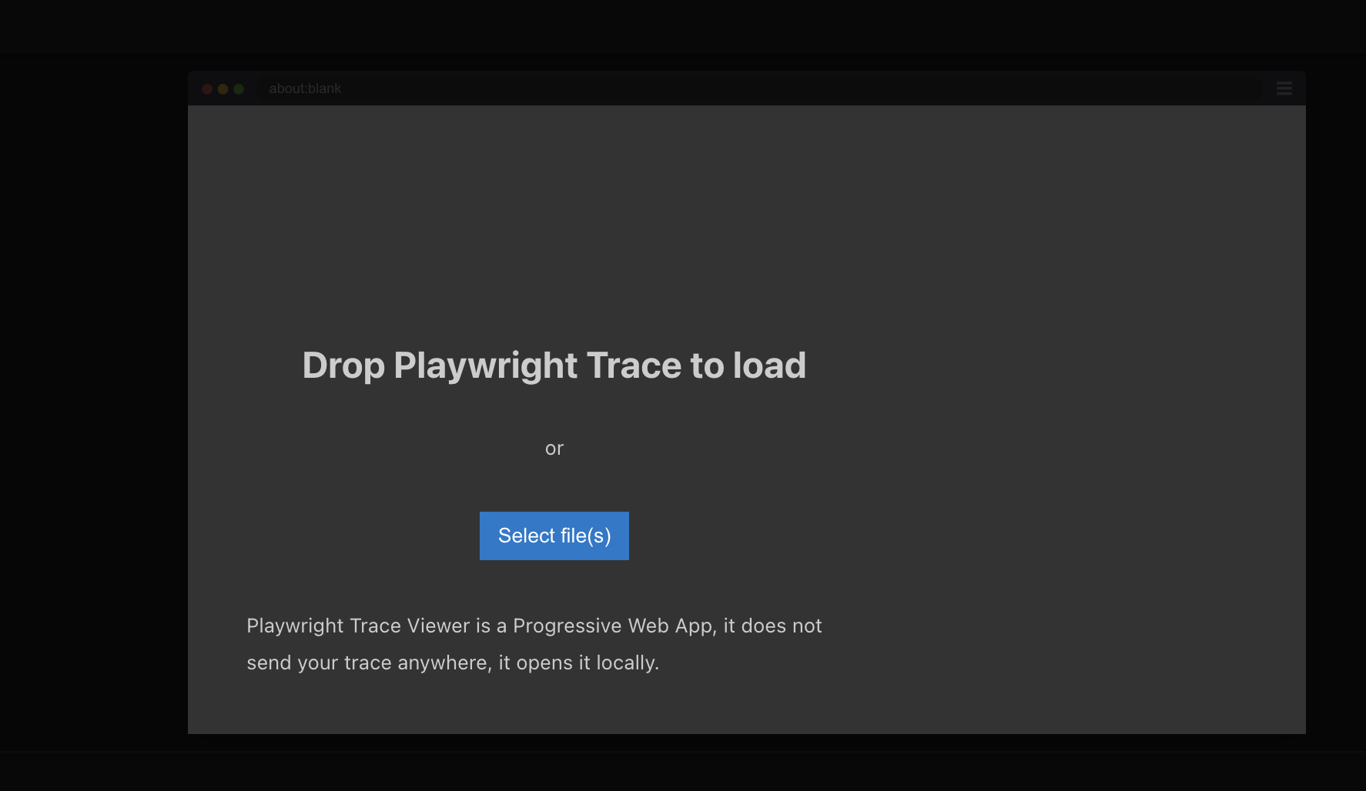

It will be displayed like the below, where you can get all the details of that particular run

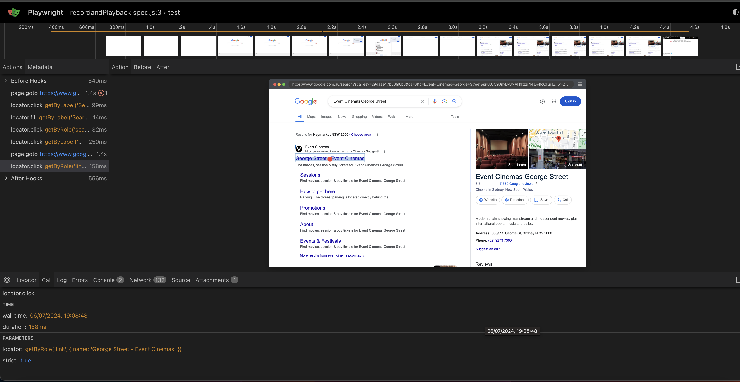

### For getting API requests for UI

Login to the site

F12

Then go to Network tab and in that Fetch/XHR

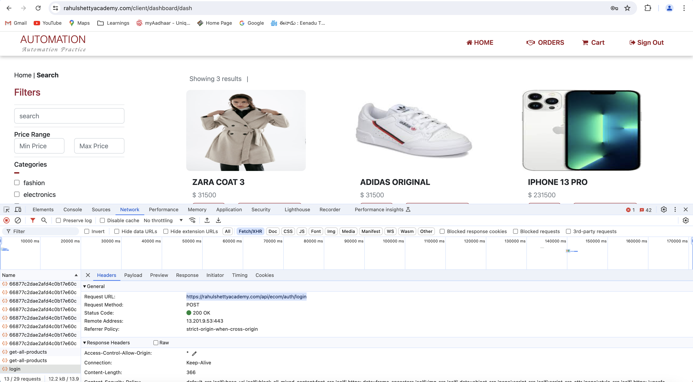

## Handling Excel using JS

Download npmjs to handle excel using JS

Go to terminal

% mkdir ExcelJSUtil

% npm init

Click enter till it completes

% cd ExcelJSUtil

% npm init

% npm install exceljs

Instead of the above command use

%npm install exceljs --savedev

With the above command others can import this directly

### For Execution

Give node excelDemo.js

## Handling Data

### Parameterizing the data

This can be done by creating a json file , which contains the input data

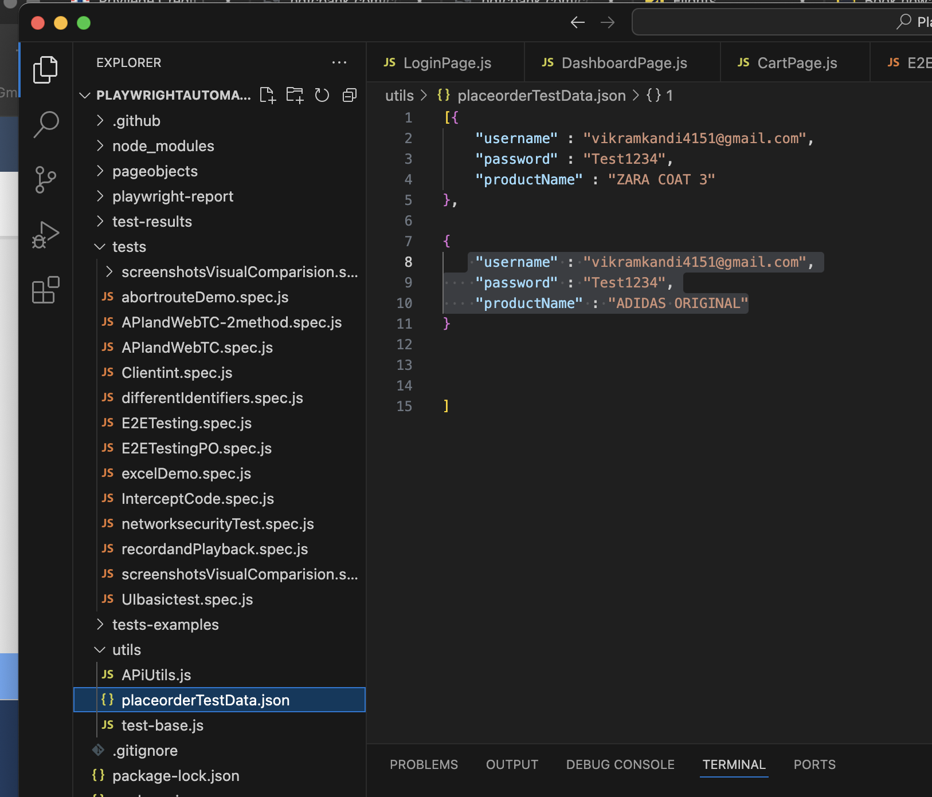

Now to use this file declare the below in the test class

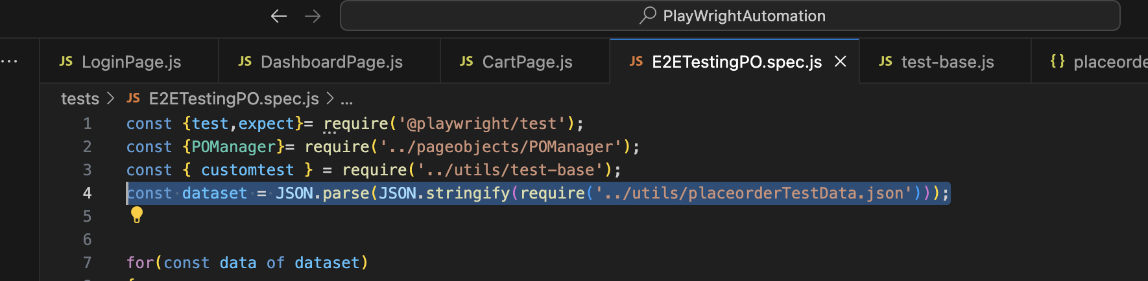

Use it by below way

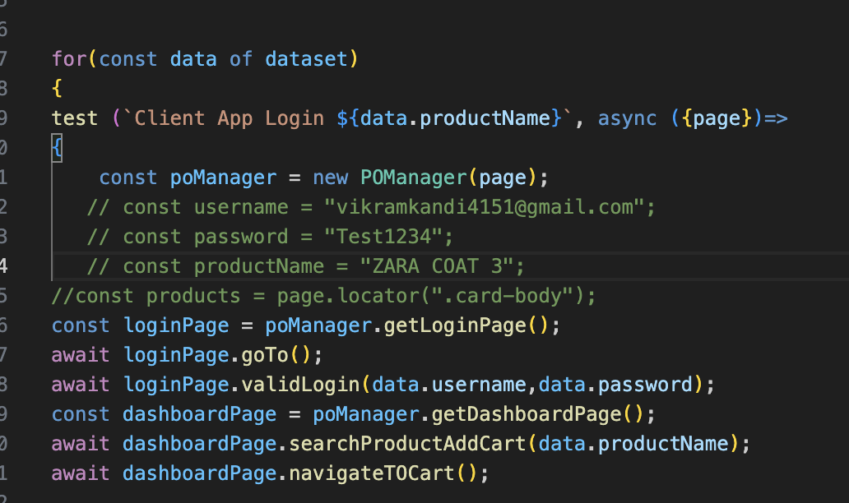

### Customizing test behaviour

Create a javascript file with the below info, to extend the features of test

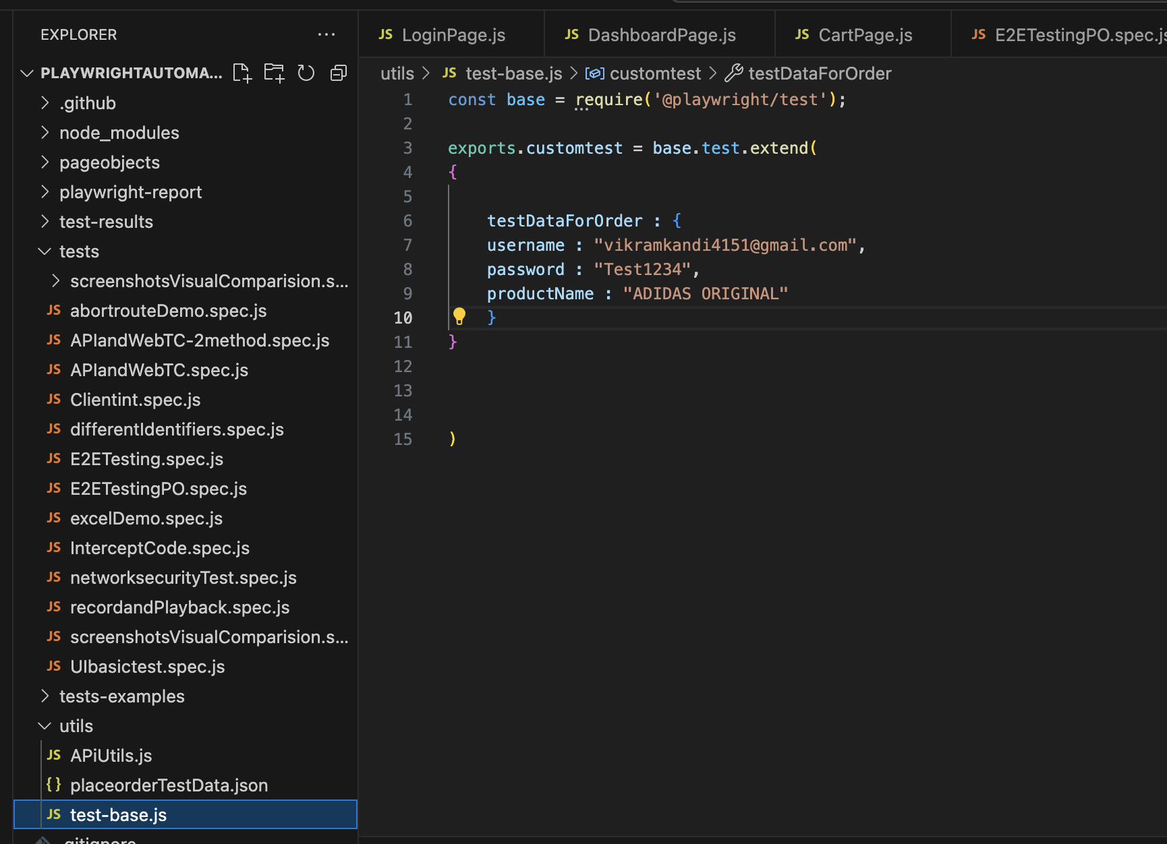

Declare the below in the class where you are calling it

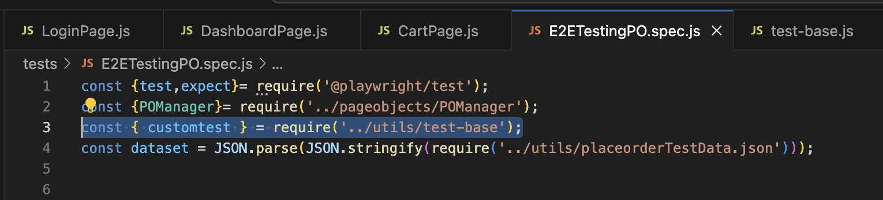

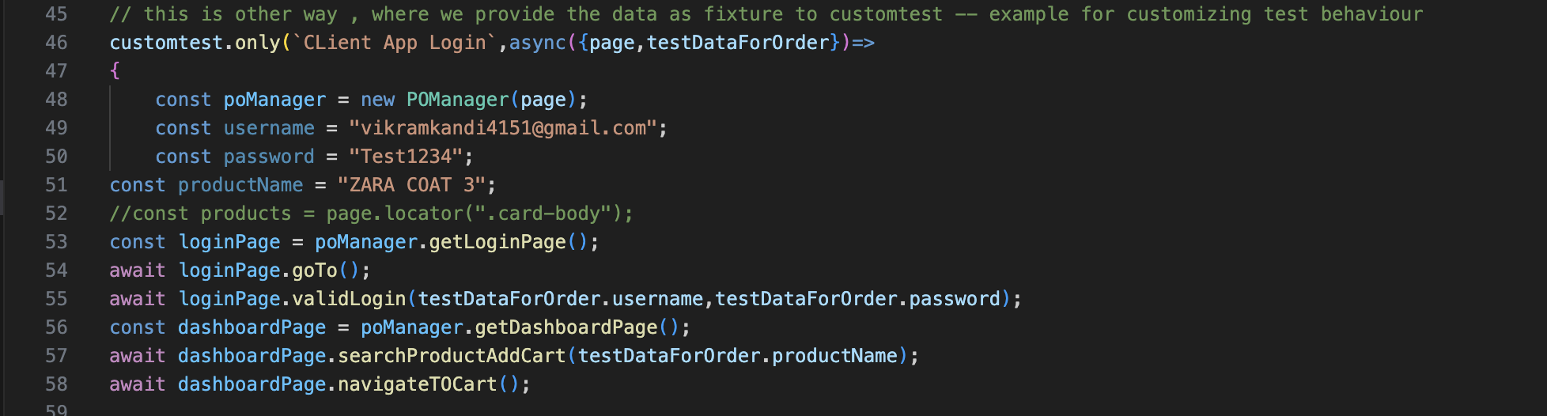

## Project Configurations

### choose and run a config files

Use the below command to run using a particular config file

npx playwright test tests/E2ETestingPO.spec.js --config playwright.config1.js

### multibrowser execution

for running the test in multiple browsers do the following in the playwright.config file

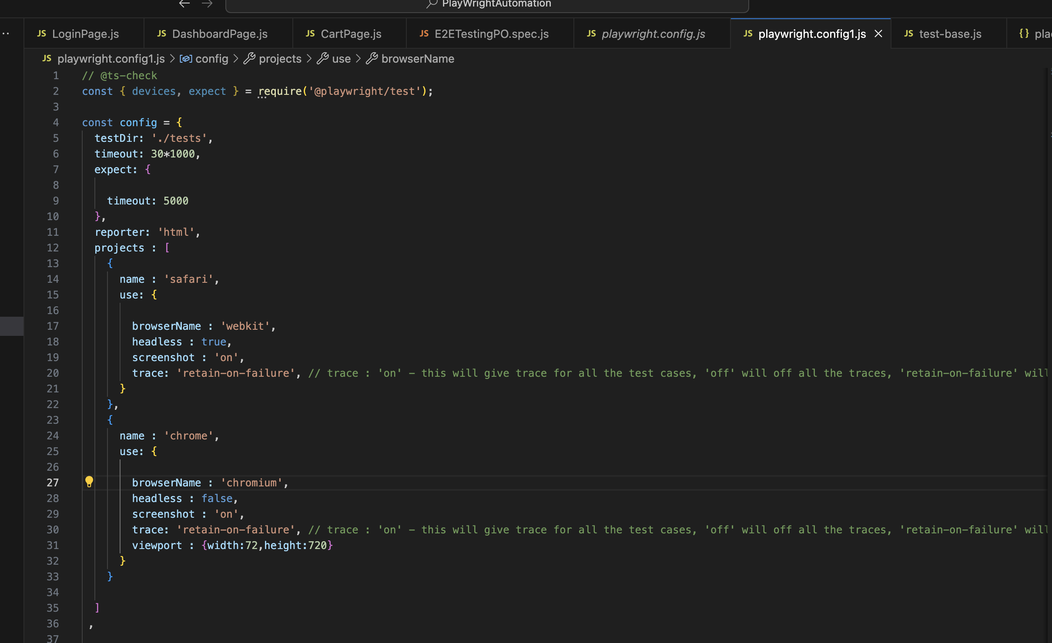

npx playwright test tests/E2ETestingPO.spec.js --config playwright.config1.js --project=safari

the above command will execute the test only on safari, if you don’t mention any project then both the browsers will be executed

### configure execution browser size

this way will help is testing responsiveness

provide the config file as below

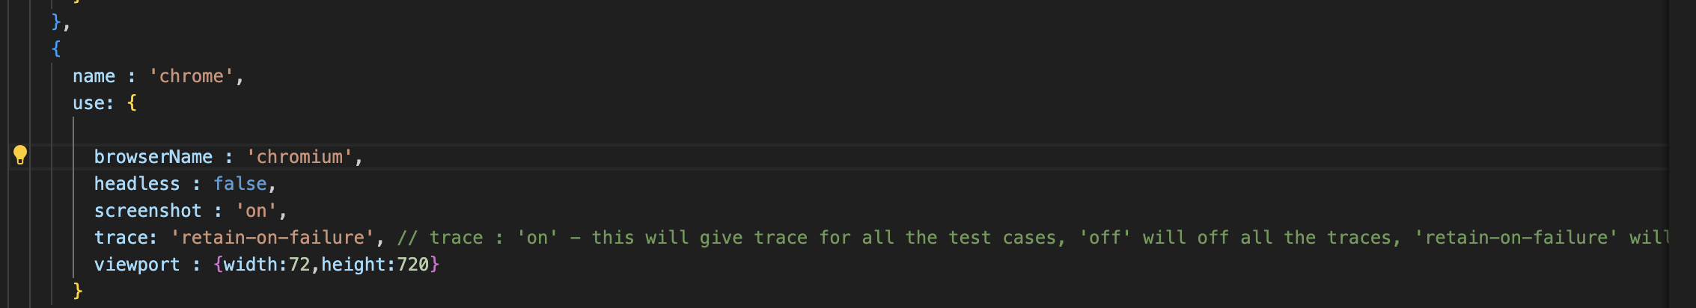

viewport : {width:72,height:720}

### choosing device browser and run

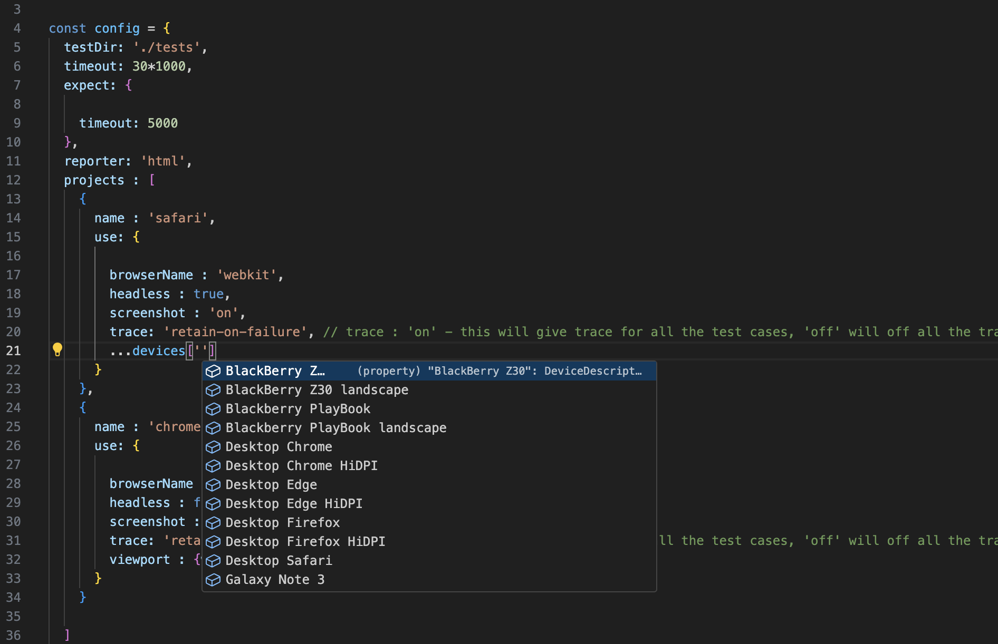

Provide …devices[‘’], suggestions come to choose a phone , select the required phone and run test

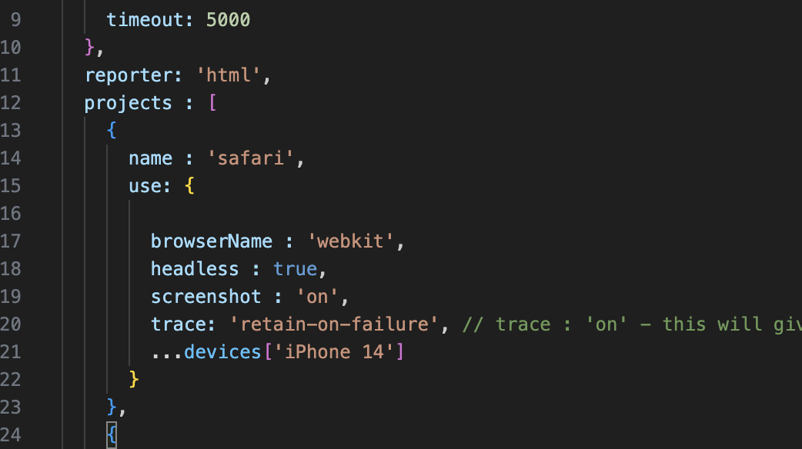

***Note: select iphone when you chose the browser as webkit and android phones for browser chosen as chromium***

### Handle SSL certification error

You need to provide

ignoreHttpsErrors: true

### Handle ‘Location pop-up’

Provide the below in browser configurations

Permissions:[‘geolocation’]

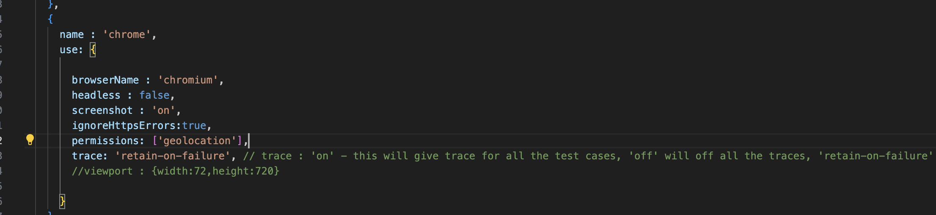

### To take video of the execution

Below are the four options available to take a video of execution

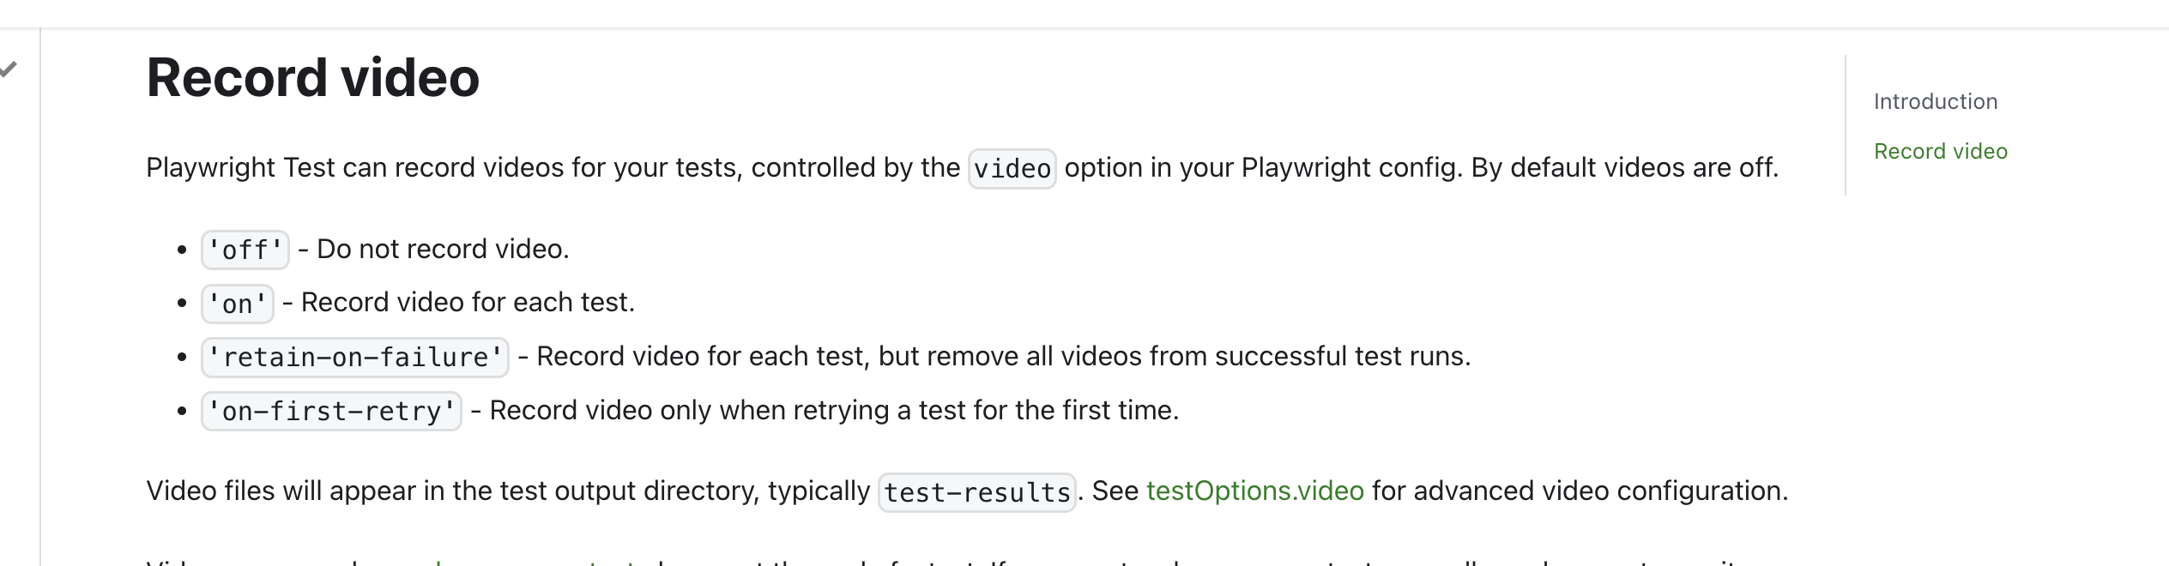

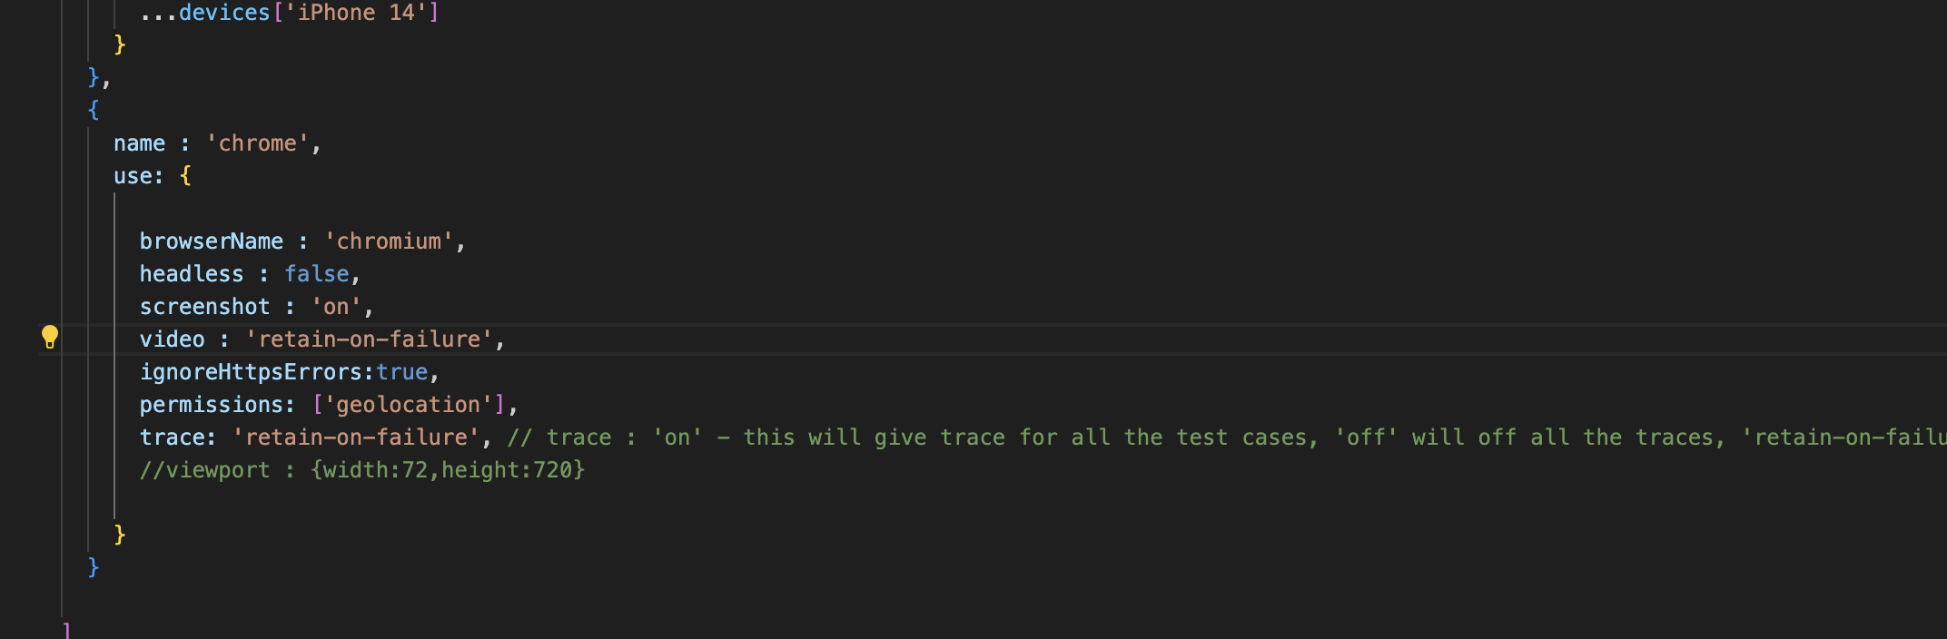

You will see the error details in browser  
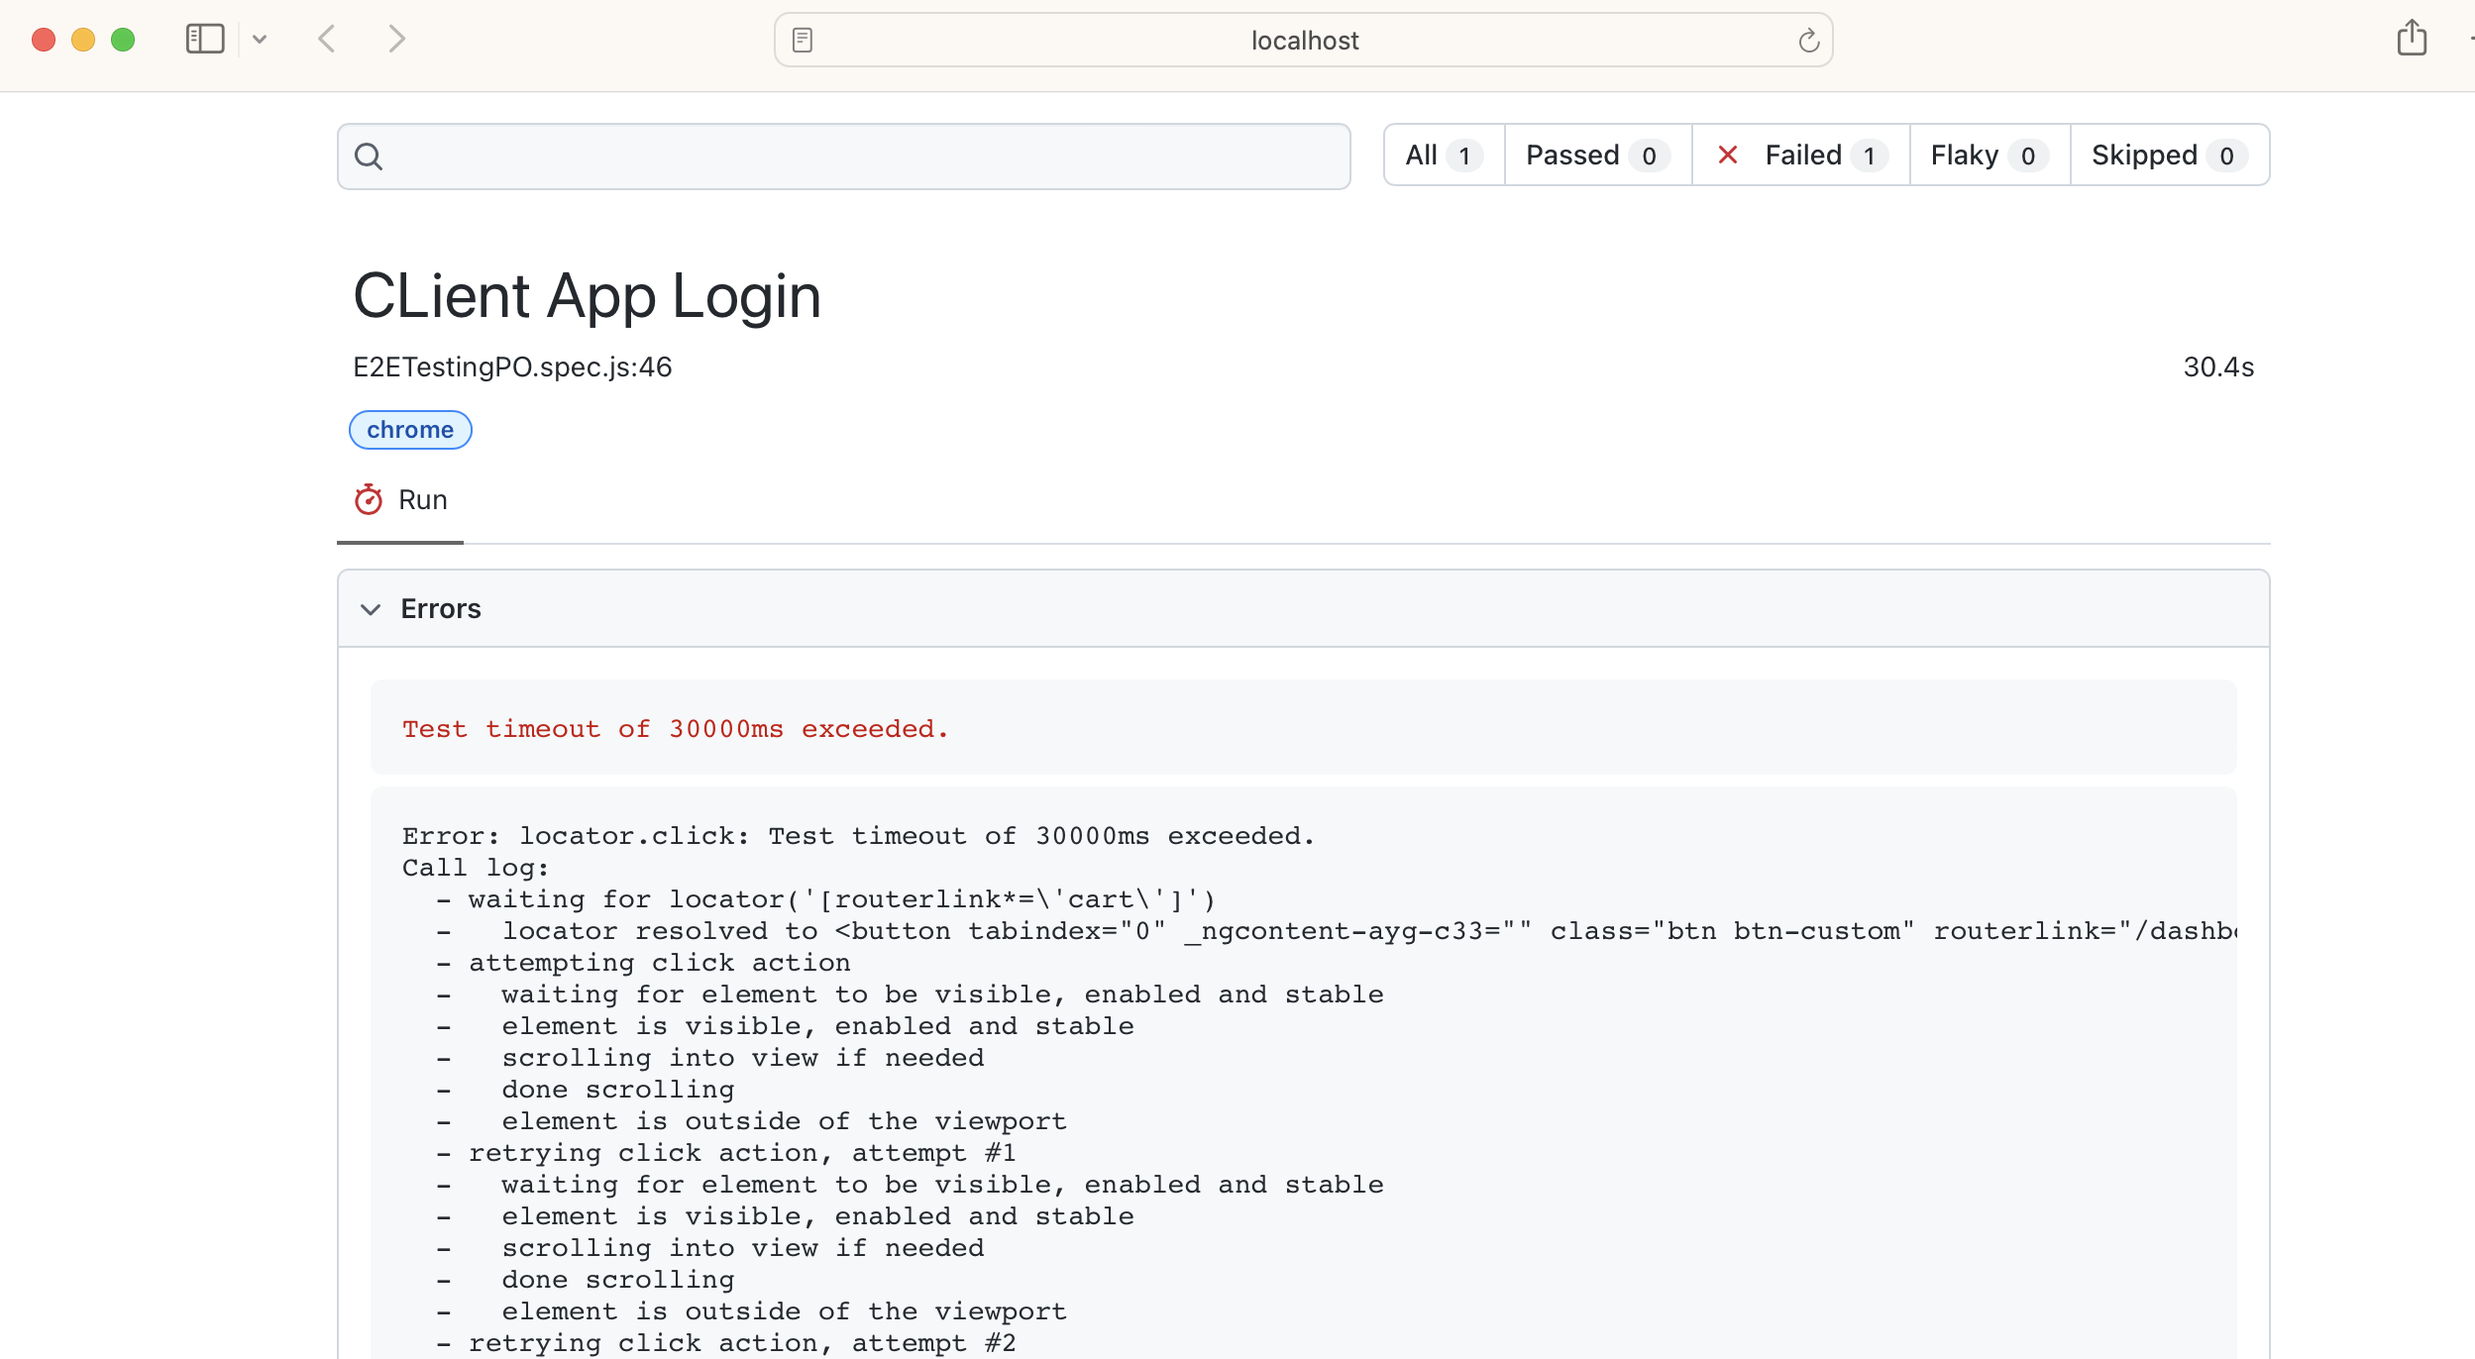

Scroll down to videos section

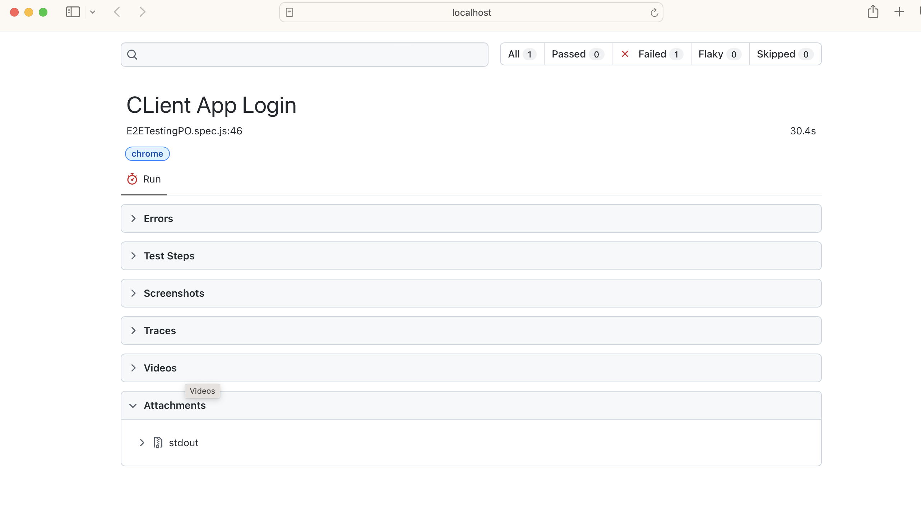

### Retry – failure scenario

To retry executing the failed scenario, you can provide the below in config file

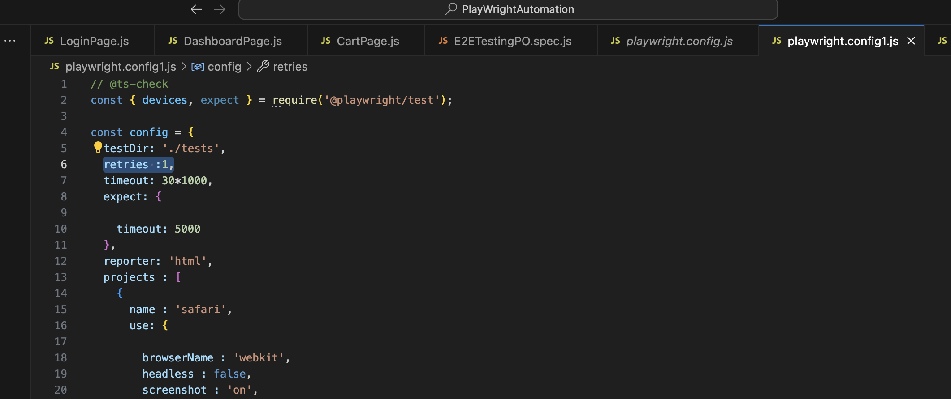

After running, I made the 3rd scenario to fail by false clicking on the browser under execution, it retried and got successful in the next retry

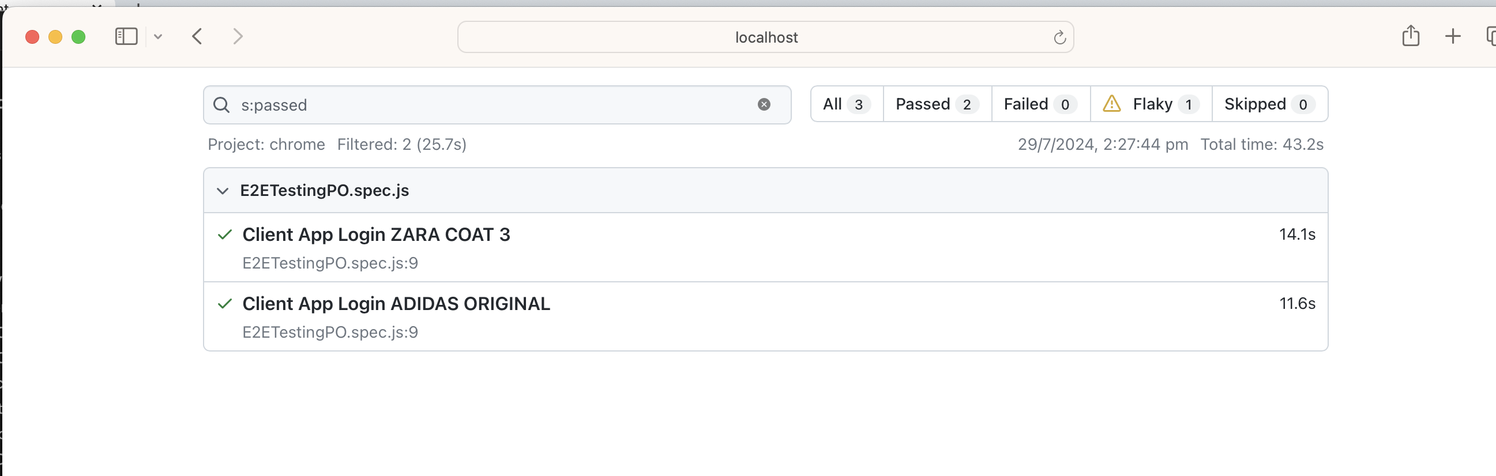

But the test case that is pass after retry is not reported under passed but in Flaky, as it failed once and passed in the retry

### Parallel Execution

By default playwright executes all the test files in parallel mode, in the console it is shown as workers

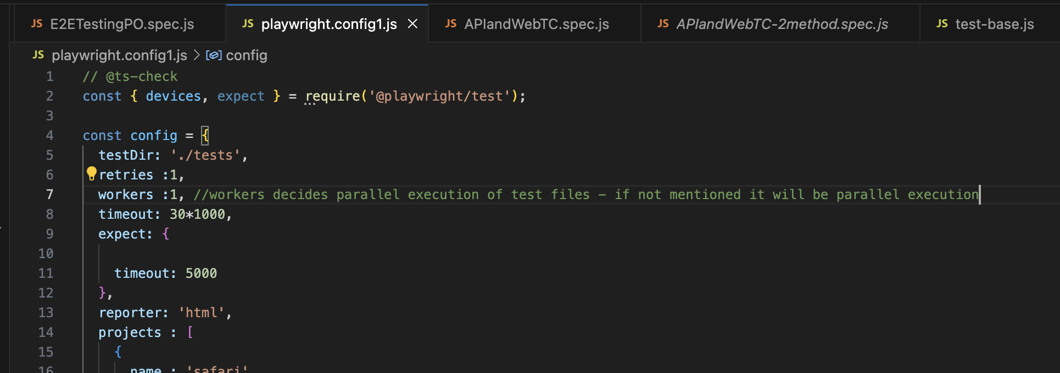

If you provide workers filed manually and gave it as 1, then all the test files will be executed sequentially

You can controller how many workers you want to run

#### To run tests in a file in parallel

test.describe.configure({mode:'parallel'});

use the above command before the test

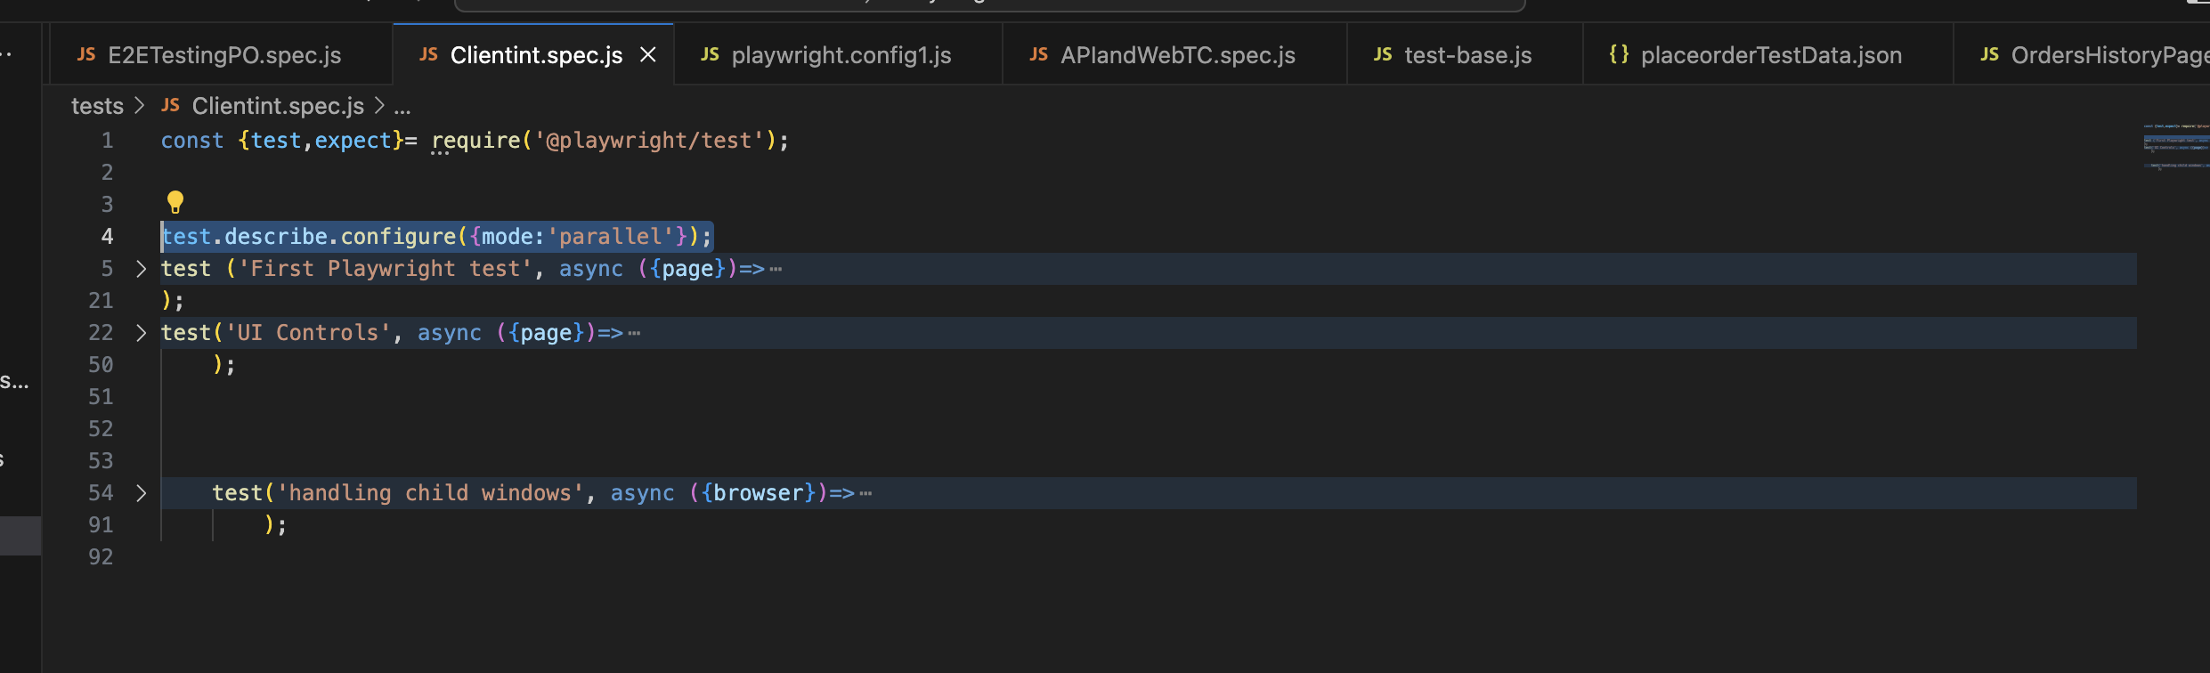

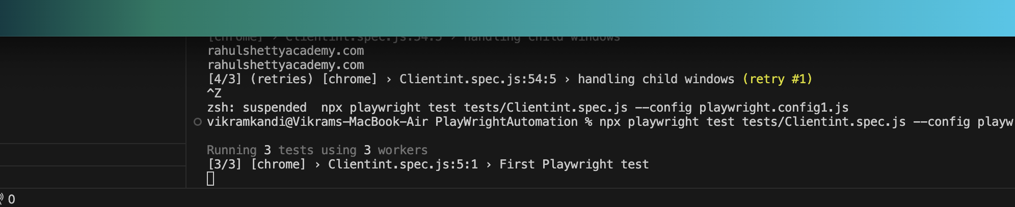

It says like 3 workers are running, so all the tests in the file are run in parallel

#### To run tests in sequential mode only

This is required when tests in a testfile is interdependent. You need to declare like below to make the tests run sequentially, if one of the test failed then execution stops(skipped) as they are interdependent.

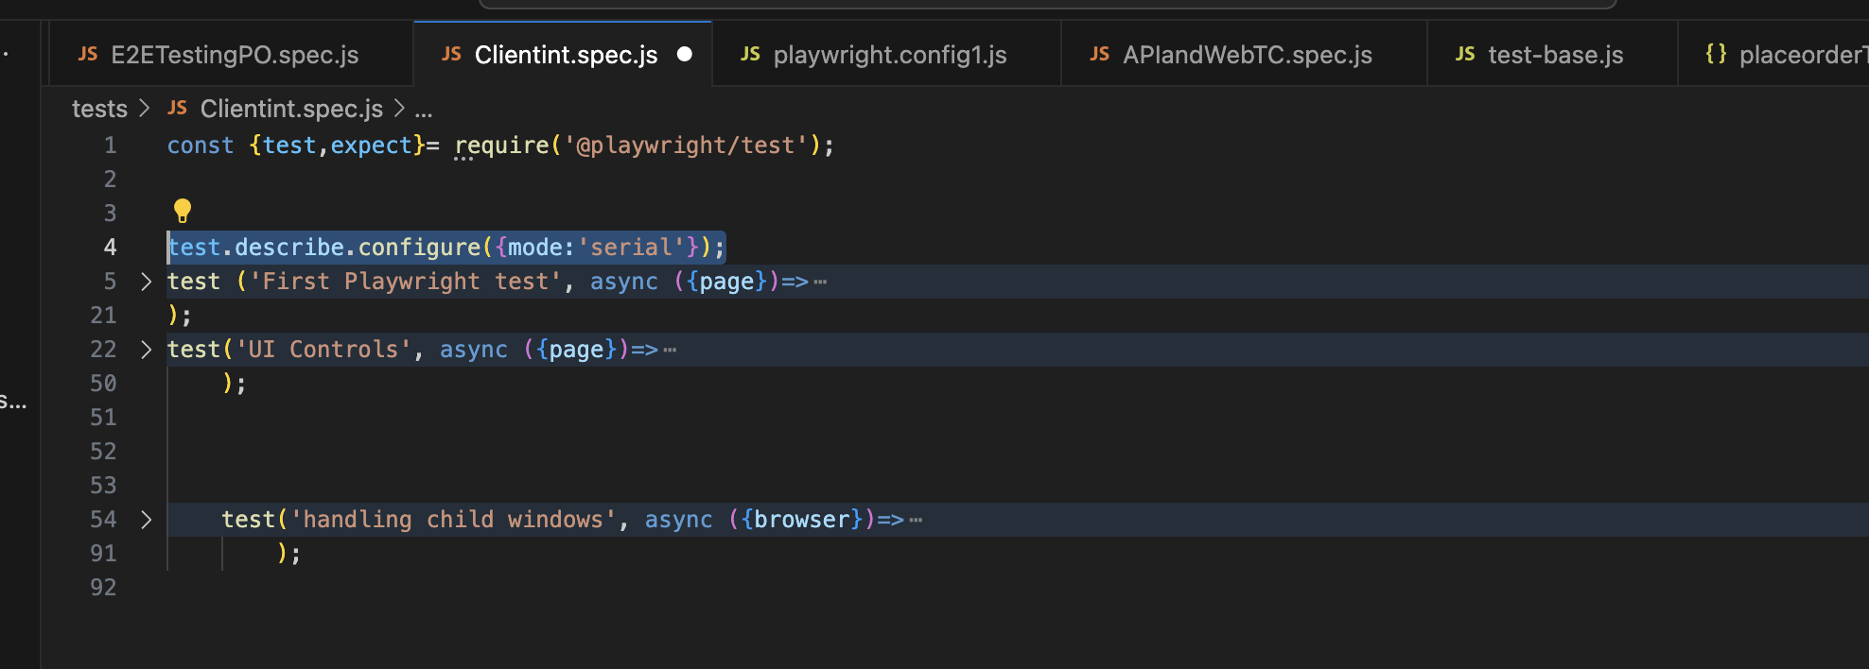

### Tagging - Run only specific scenarios

You can give a prefix for the test cases that come under a group and can call them with regular expression while running.

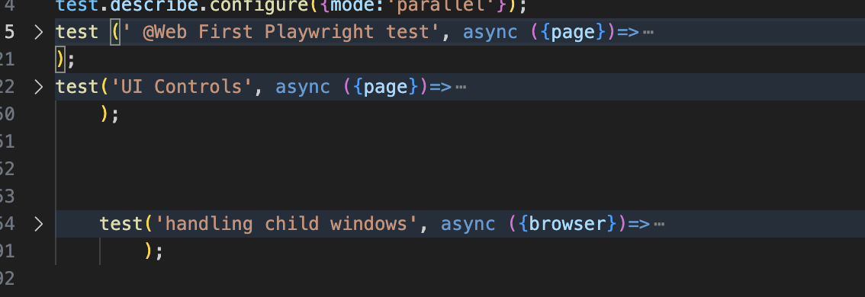

While running provide the below

%npx playwright test --grep @Web

The above command checks for all the tests that has @Web as prefix and runs only them.

This is useful for segregating, api tests from UI tests, for running smoke tests, regressions tests etc.

## Install Allure reporting

% npm i -D @playwright/test allure-playwright

% npm i -D allure-commandline

The above command from the project folder will install the allure reporting in that particular project

Run with the following command for allure report to get generated

% npx playwright test tests/Clientint.spec.js --reporter=line,allure-playwright

After the execution is done, give the below command to generate allure report

% npx allure generate ./allure-results –clean

## Running Custom scripts from Package.json

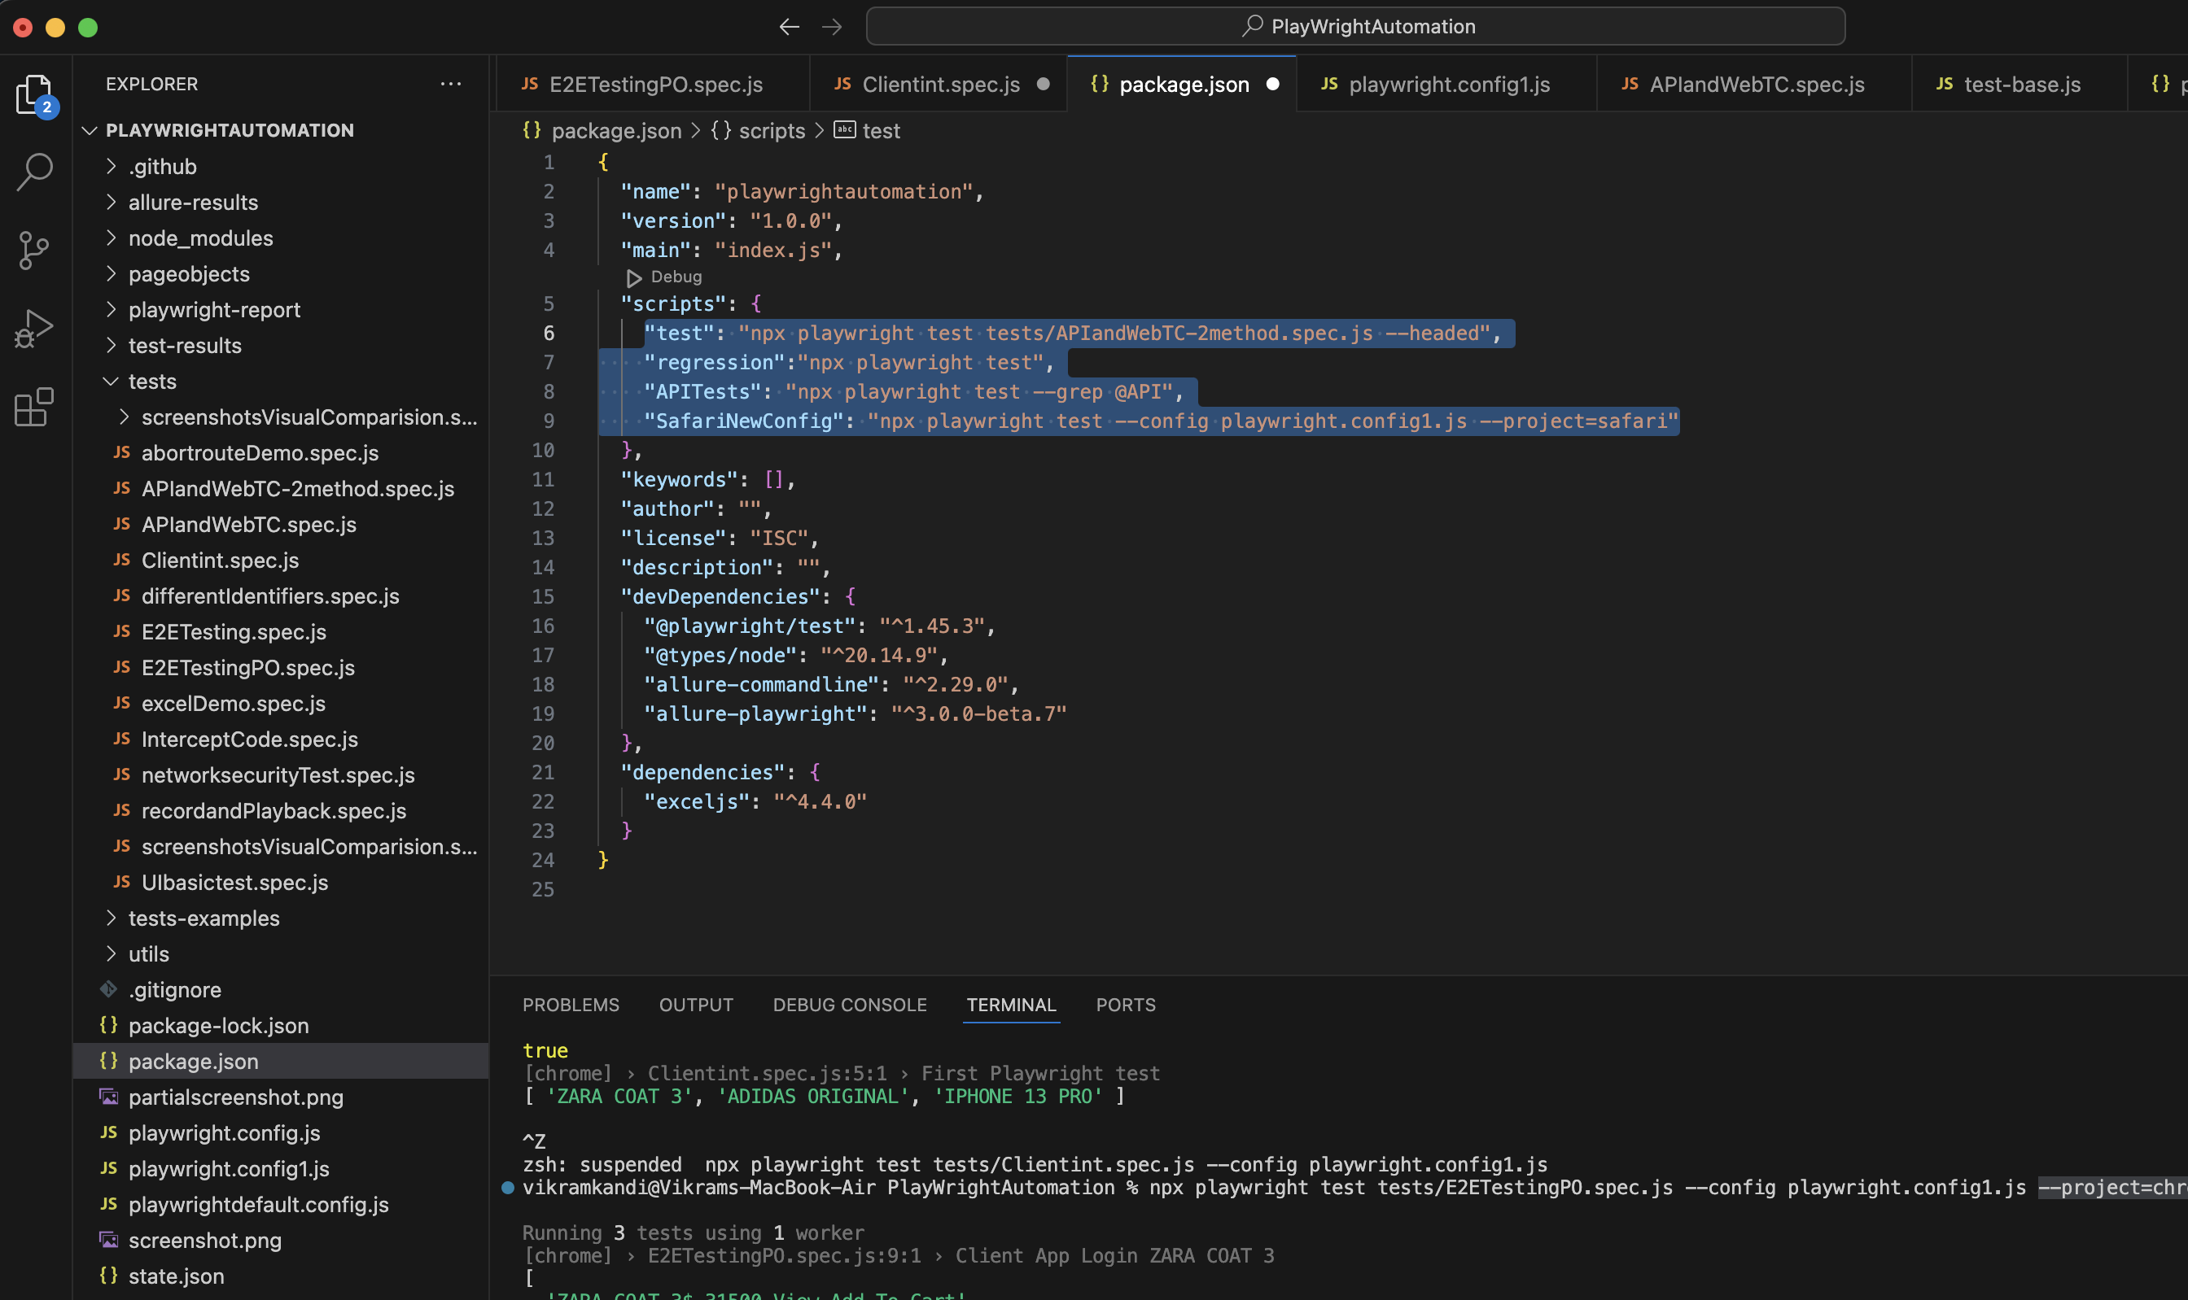

You can define the custom scripts in package.json and run them from command line

%npm run test

Or

@npm run SafariNewConfig

## Install and Configure Jenkins

### Setting up Java

echo $JAVA_HOME – gives java home path in MAC

to change the jdk to latest version, download the latest DMG from java site

run and install it

to configure latest version, copy the path ideally (/Library/Java/JavaVirtualMachines/jdk-17.jdk/Contents/Home)

if the profile is zsh then

% vim ~/.zshrc

Update the latest JAVA_HOME path and save (esc :wq!)

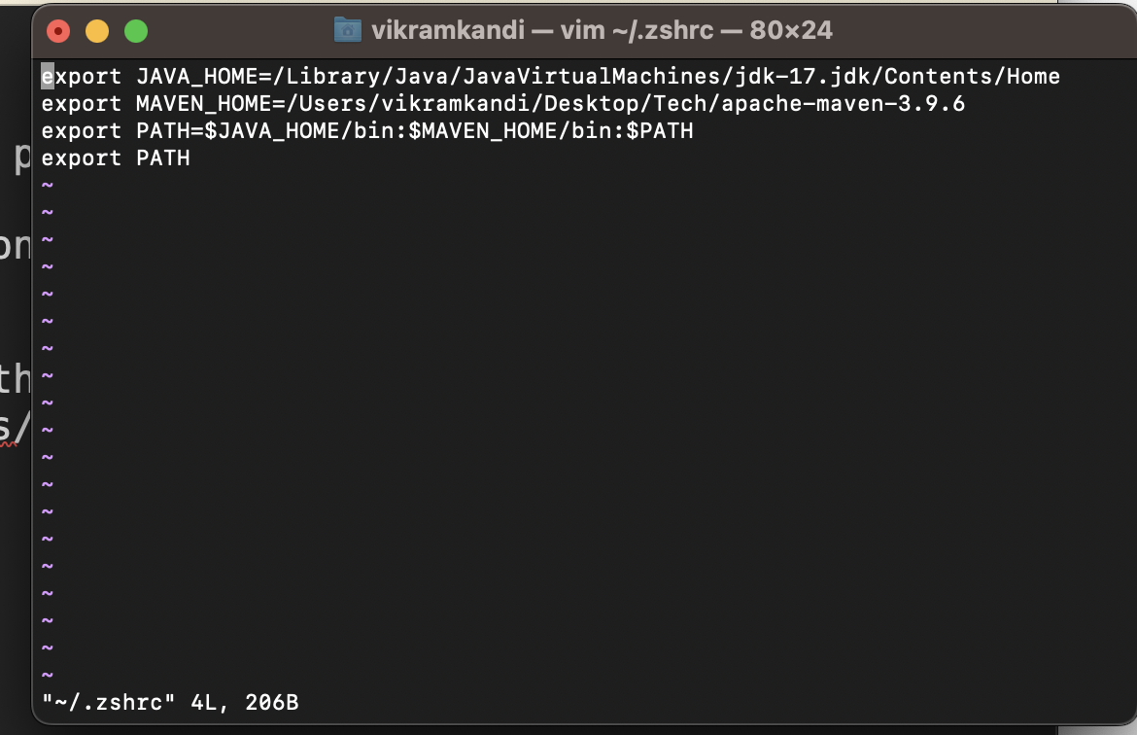

Now the configuration to reflect source the changes

% source ~/.zshrc

Now check the java home by

% echo $JAVA_HOME

### Setting up Jenkins

Downalod Jenkins.war file from Jenkins site

Copy it to a folder and note the path

In the terminal go to that folder and give the below command

% java -jar Jenkins.war httpPort =9090

The above commands starts Jenkins in local on port 9090

Now give the url (<http://localhost:8080>) in the browser

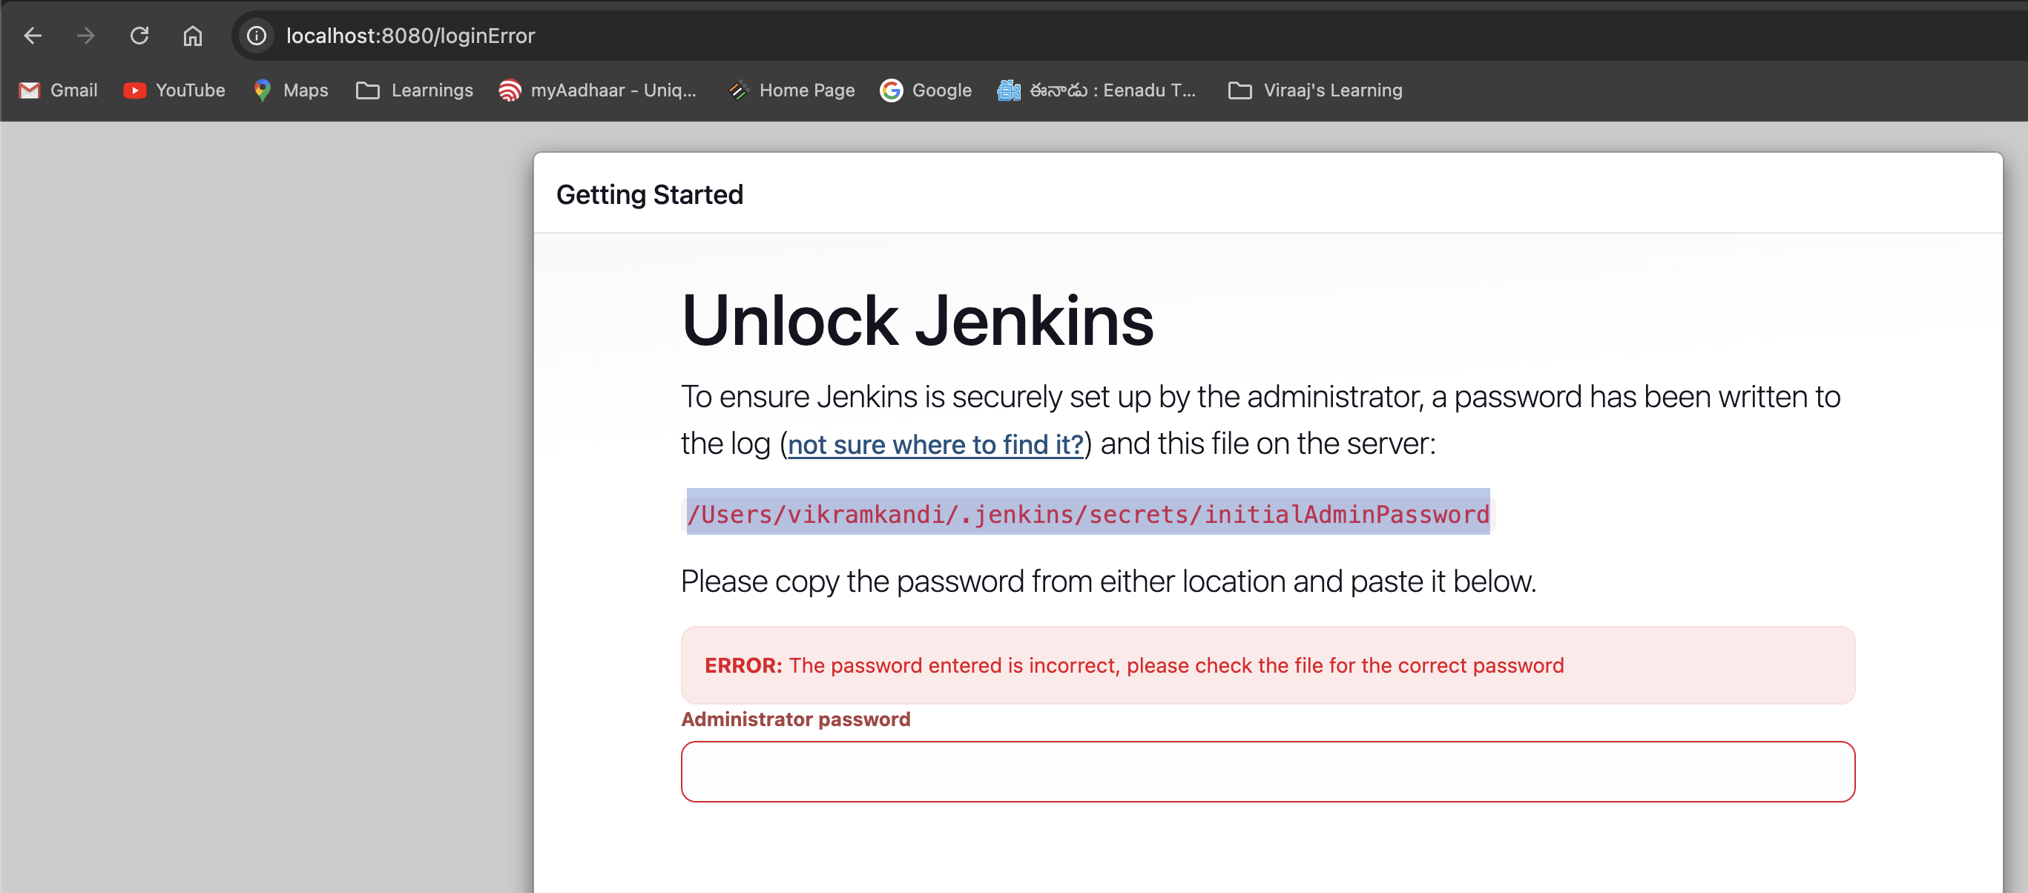

It asks for password and that it is available in the terminal window where you have started Jenkins

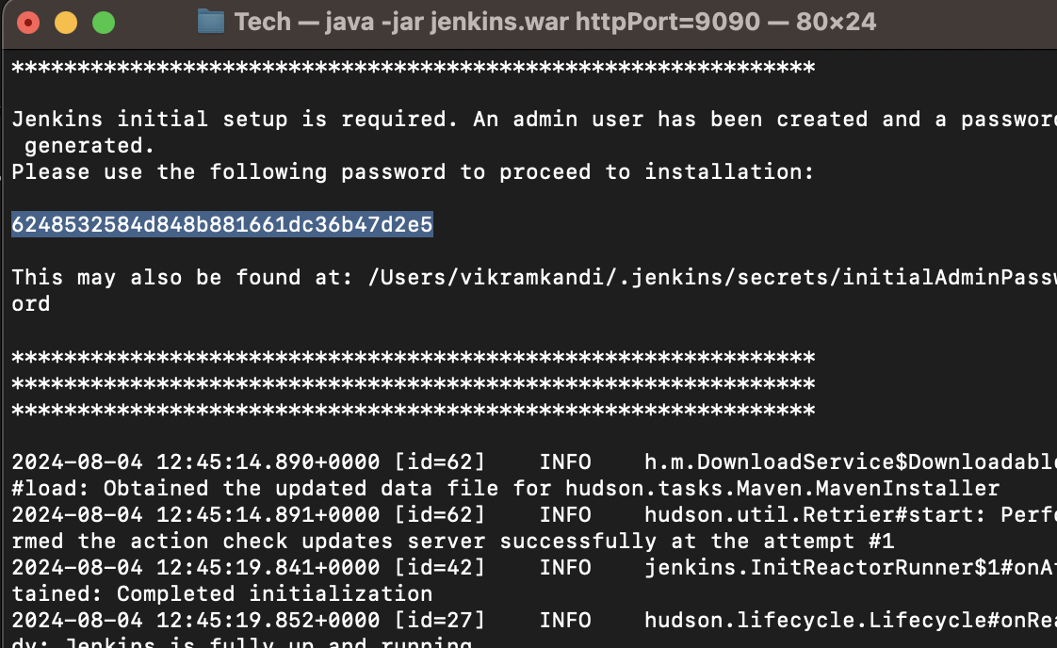

6248532584d848b881661dc36b47d2e5

It asks for some configurations and after that you can view the dashboard page

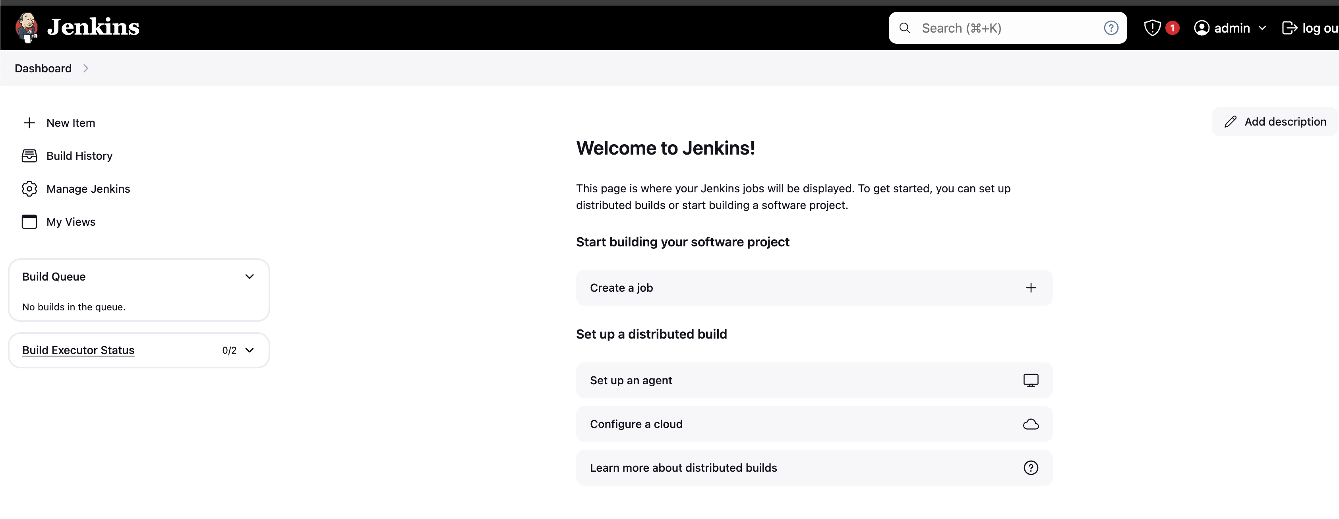

### Setup new job in Jenkins

Click on new item

Give a name for the project and select free style project

Now the configuration page opens

If you are using the project from git , you can provide the url below  
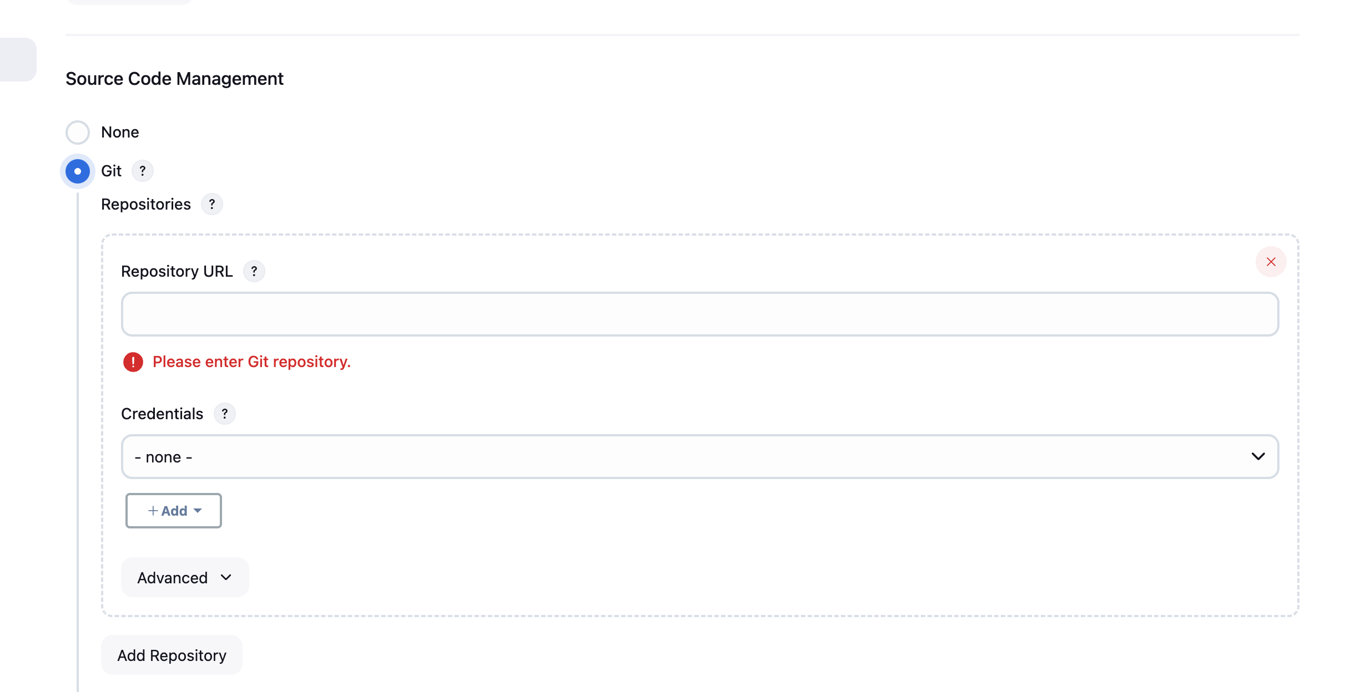

If it is from local

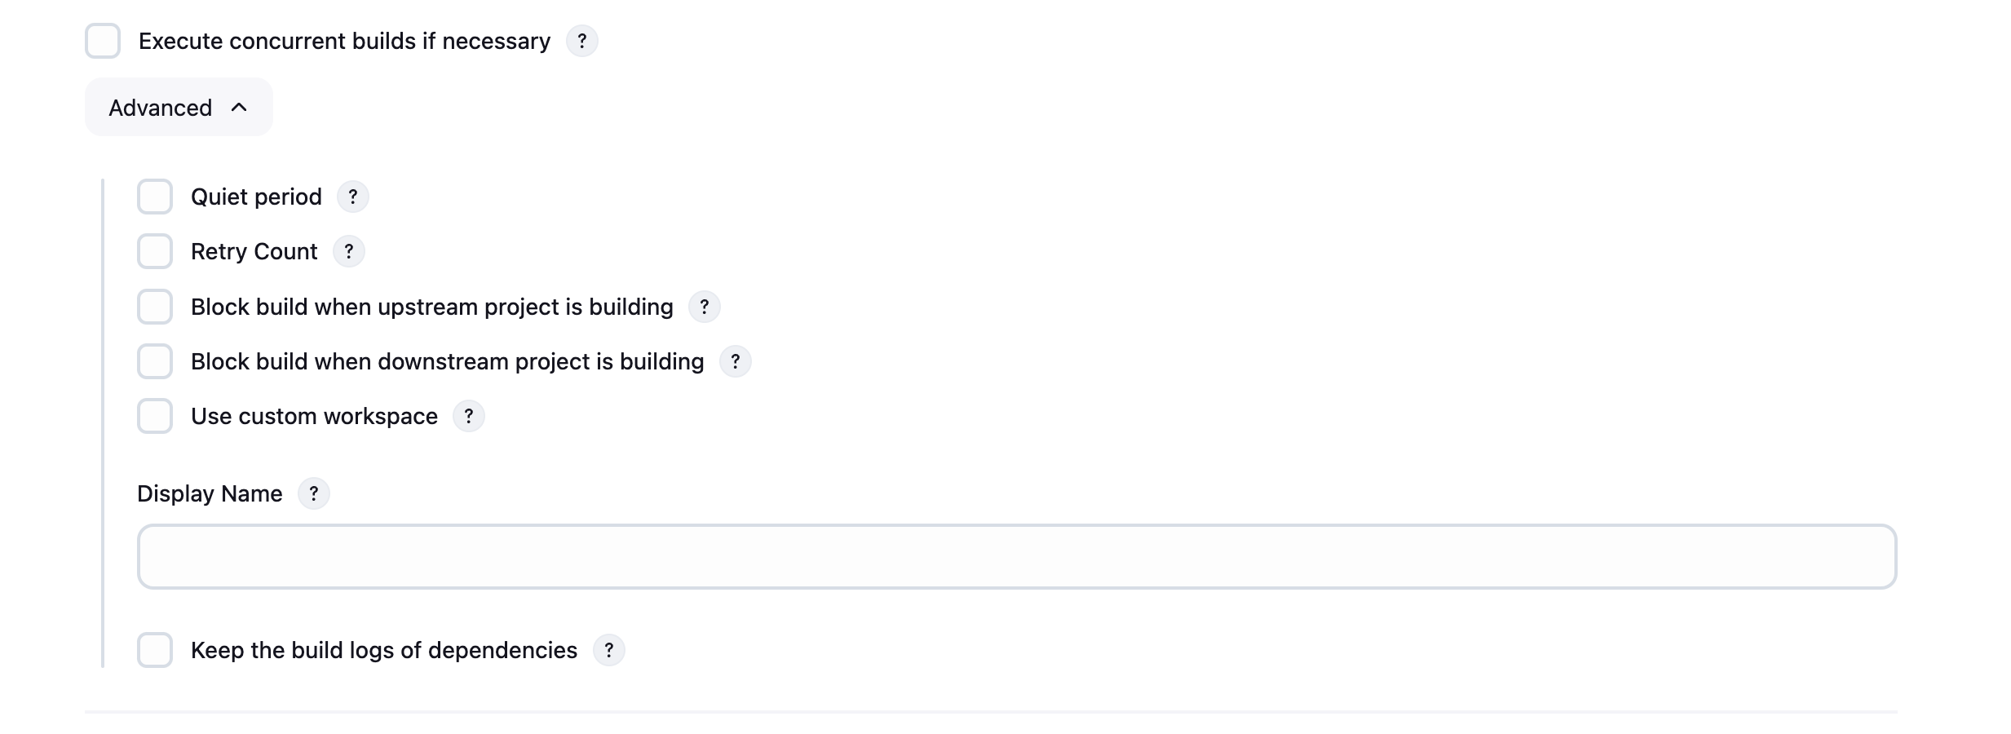use custom workspace

To get the path, go to any of the files in the editor (VS code , right click on package.json – revel in finder --- copy the path

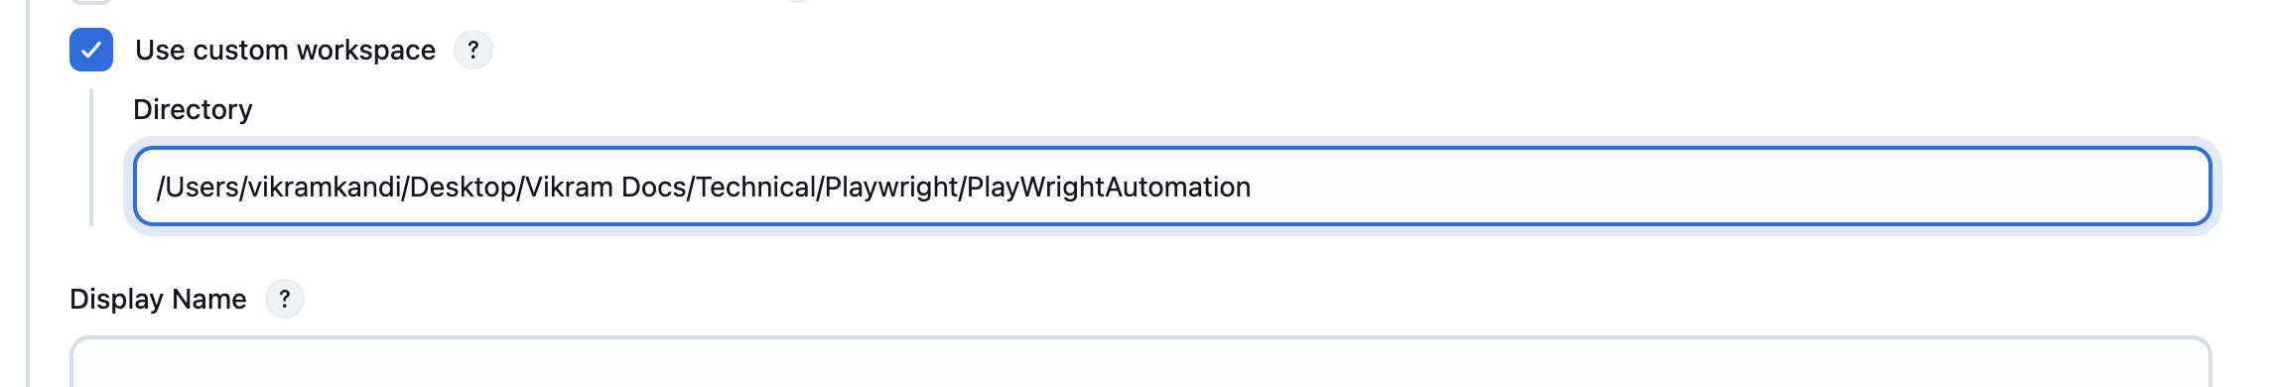

Now go to build steps and select Execute shell for MAC

provide the run command ( npx playwright test tests/E2ETestingPO.spec.js)  
save and click on build

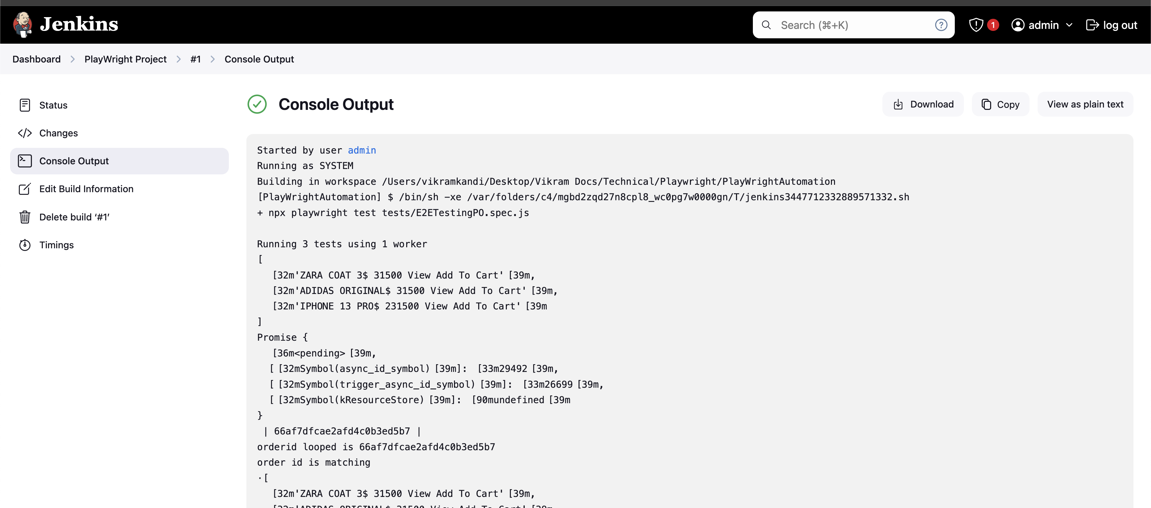  
you can see the logs in Jenkins

### Parameterizing the test name

To parameterize the test name go to configuration in Jenkins

Select below option

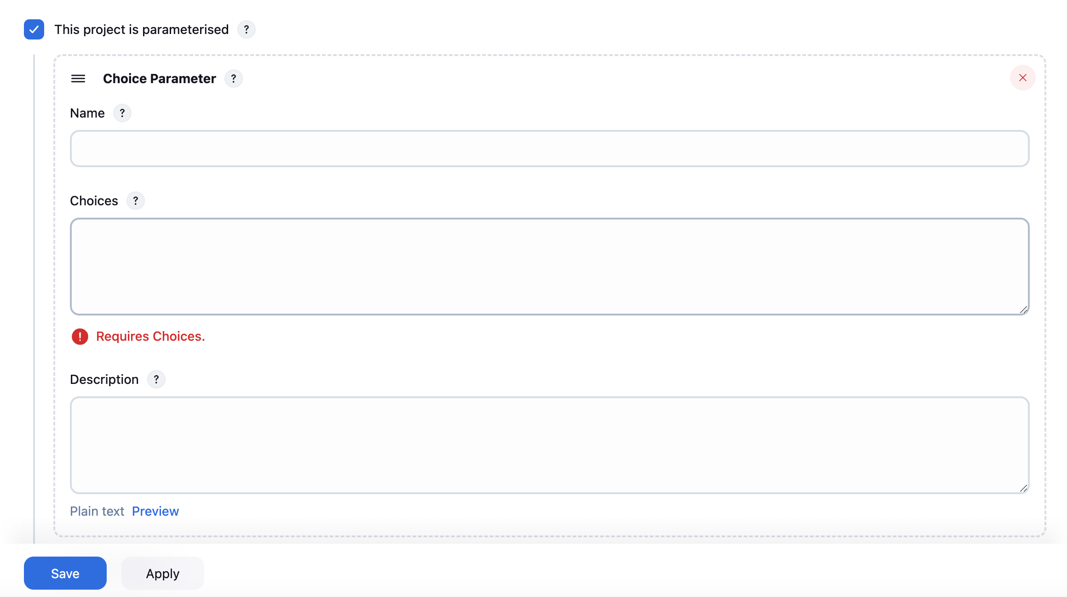

Fill the details

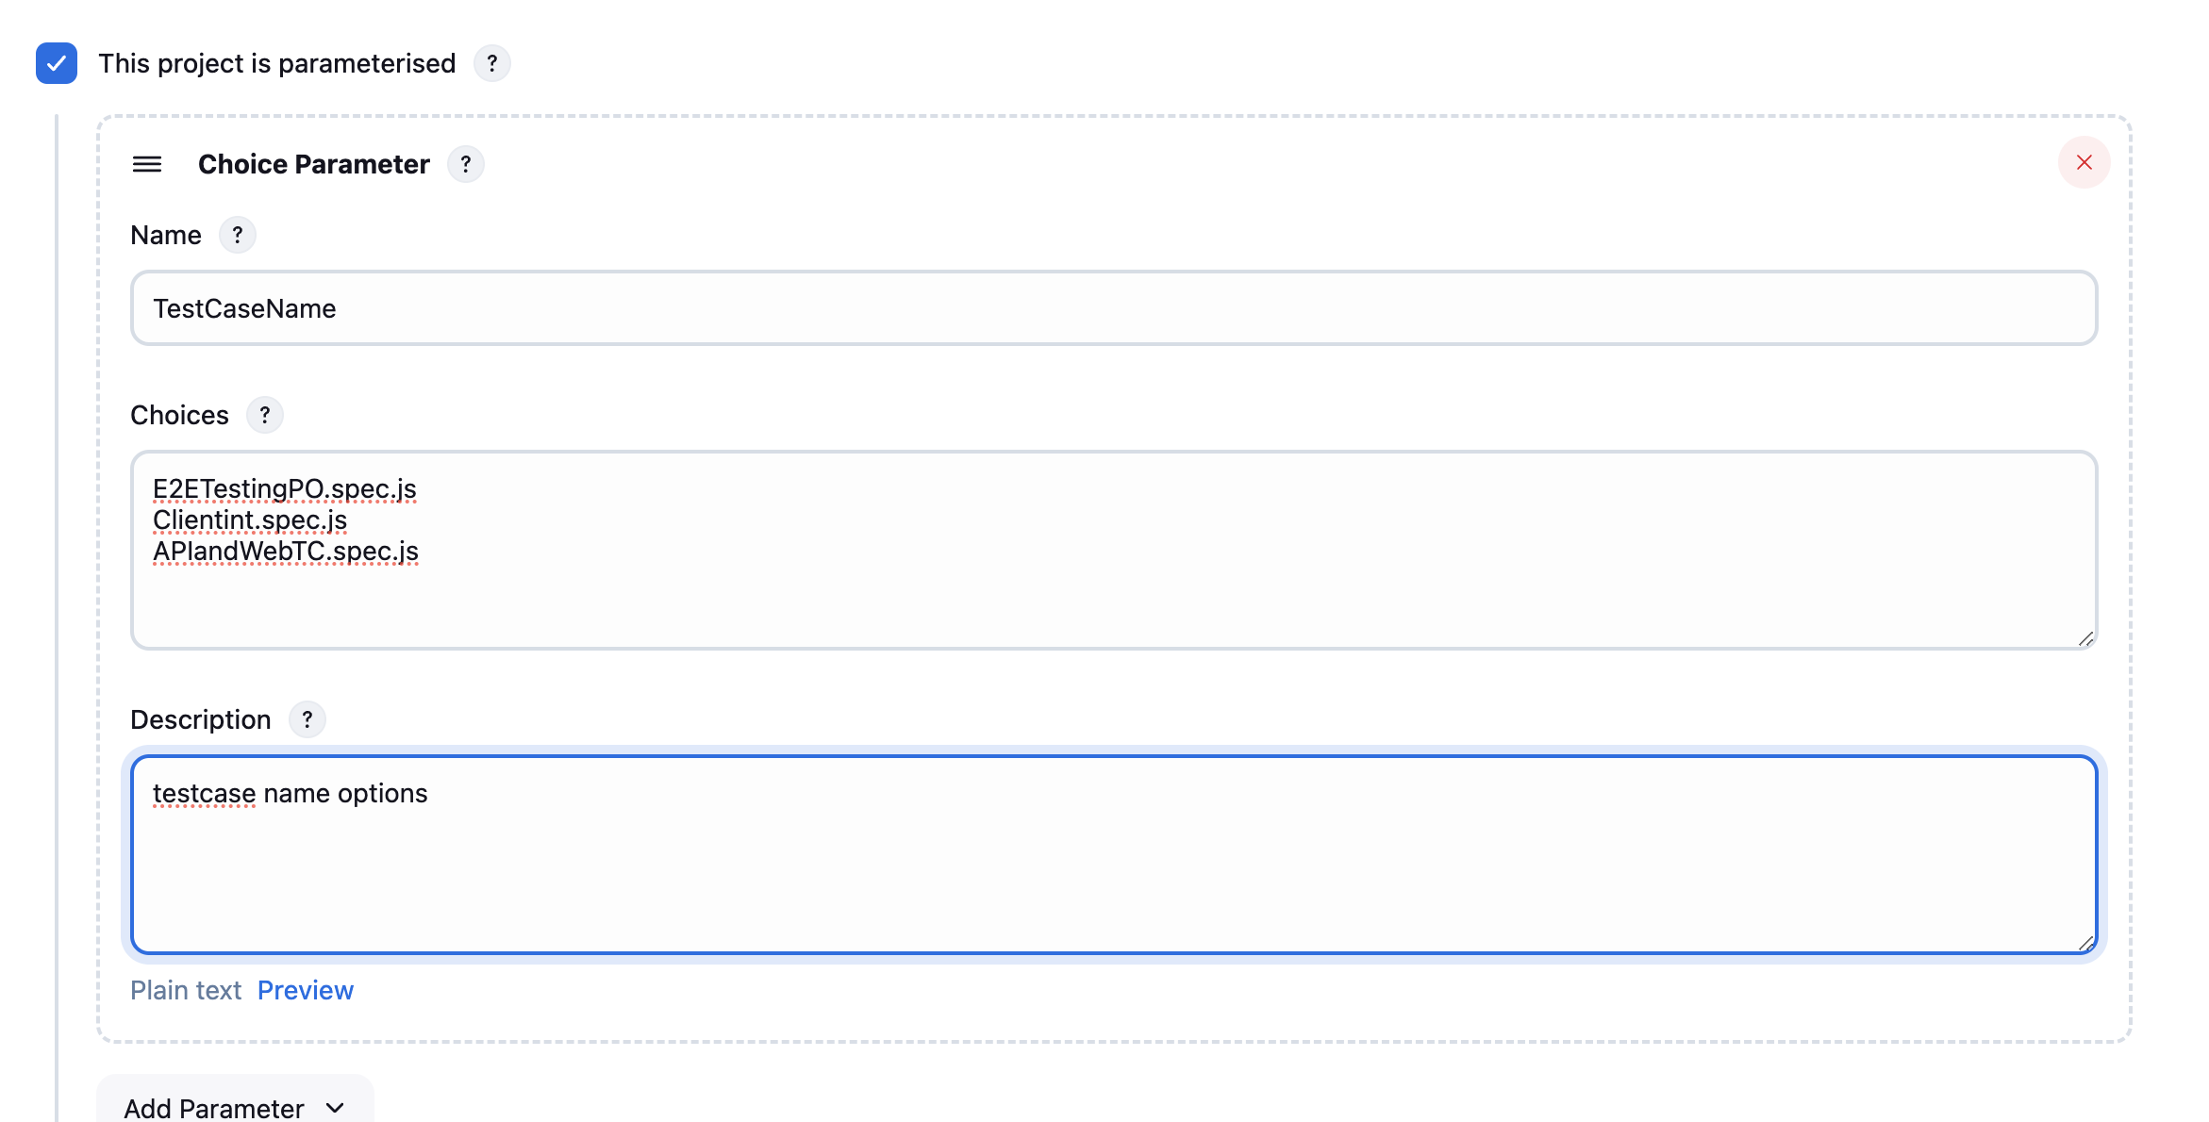

Now for that place you want to parameterize provide the parameter

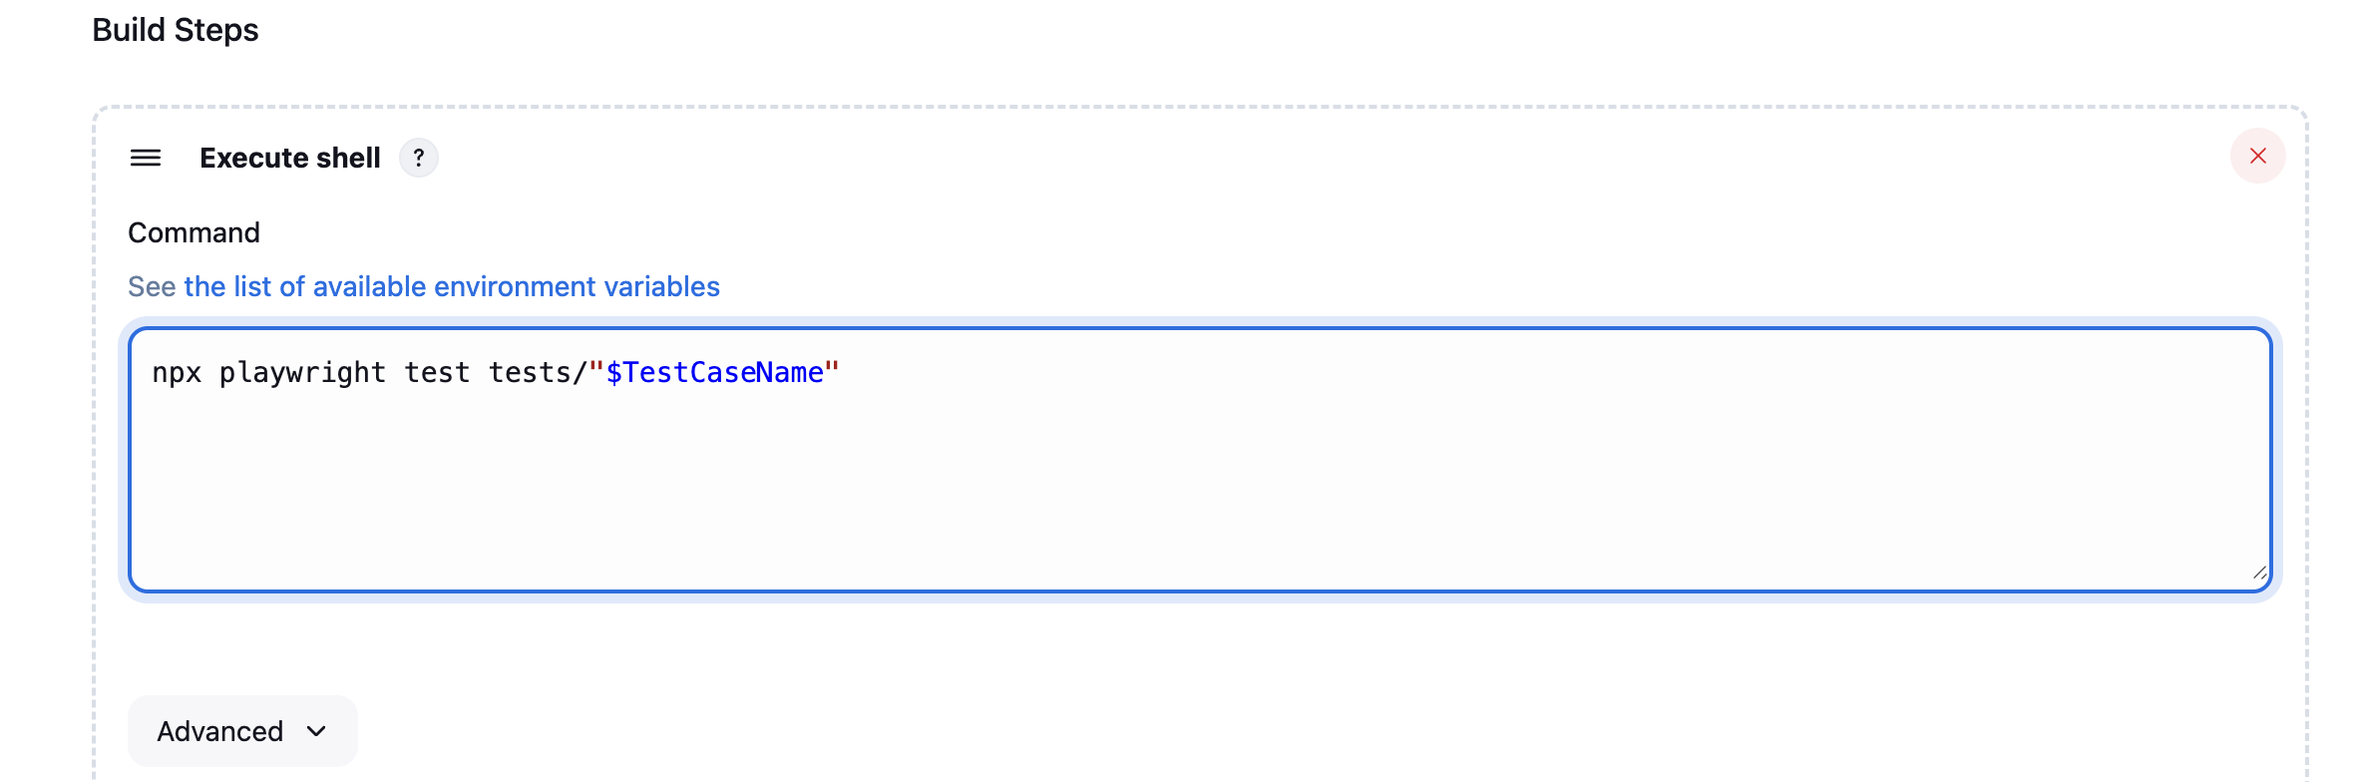

Now in the dashboard page the build option turns to build with parameters , as we added one parameter

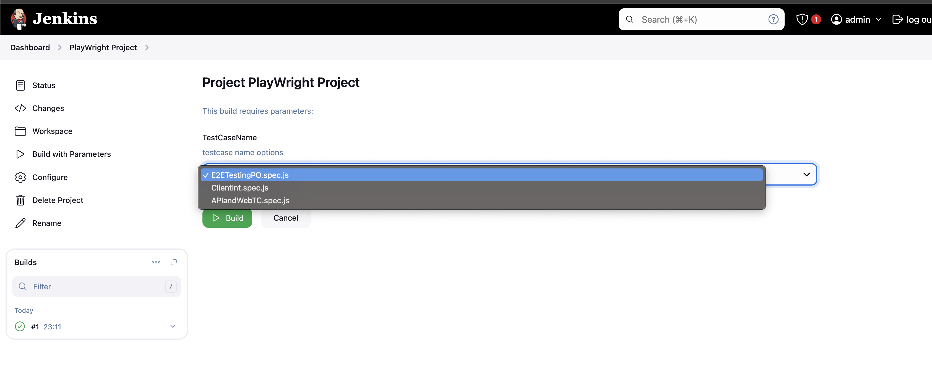

Select and run the build

For Windows

Slect ‘Execute Windows batch command’ instead of Execute shell and the parameter should be given like

npx playwright test tests/"%TestCaseName%"

### Commands

Command in the build can be below

npx playwright test tests/"$TestCaseName"

or if the run config is mentioned in package.json like below

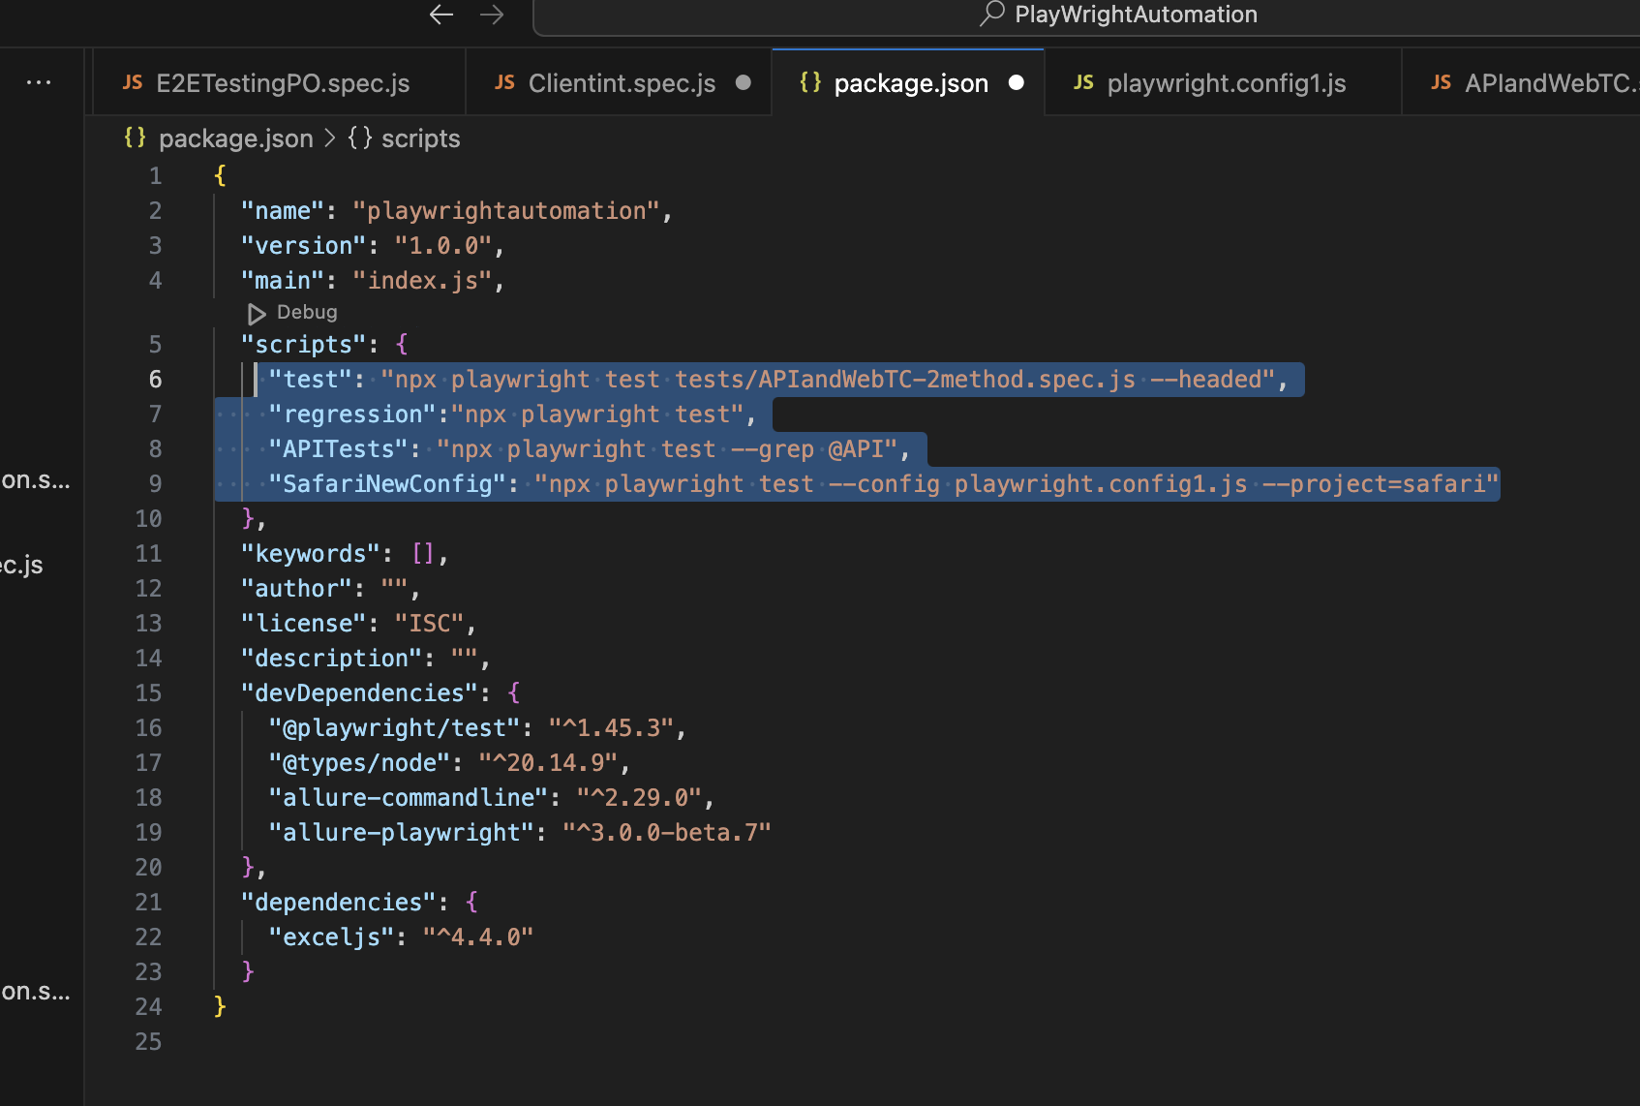

Then the command given in Jenkins or from command line will be

npm run test

Or

npm run SafariNewConfig

or

npm run APITests

or

npm run regression